Business Connect

Planmember Connect 🡪 Business Connect :

Once every rep logged into planmemberpartners.com, it will redirect to planmember connect screen.

In Business Connect we have different sections

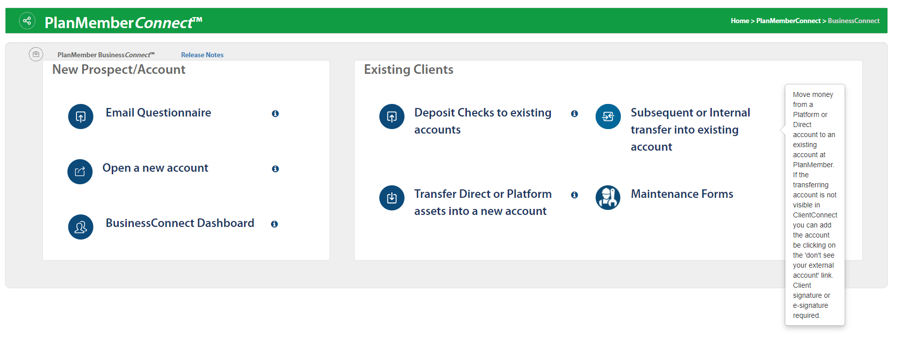

1.Email Questionnaire

If rep don’t know any details of Client and if he/she want to fill all the details by client, then re will select Email Questionnaire.

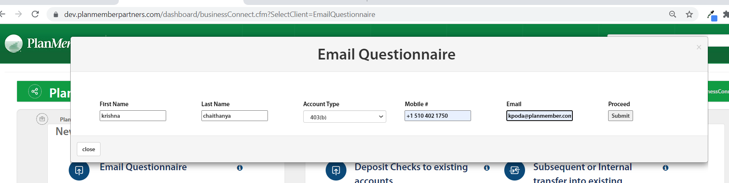

If we click on submit after filling all the data, it will redirect to another screen and display email content.

Once we click on send email to client, it will send mail to mentioned mail address and send passcode to mentioned mobile number

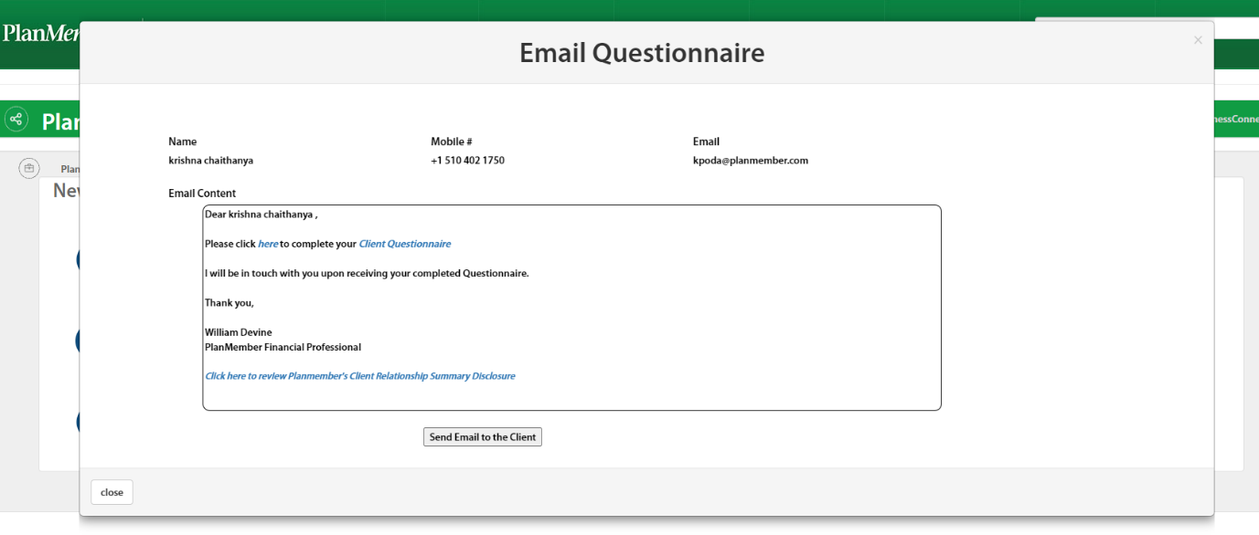

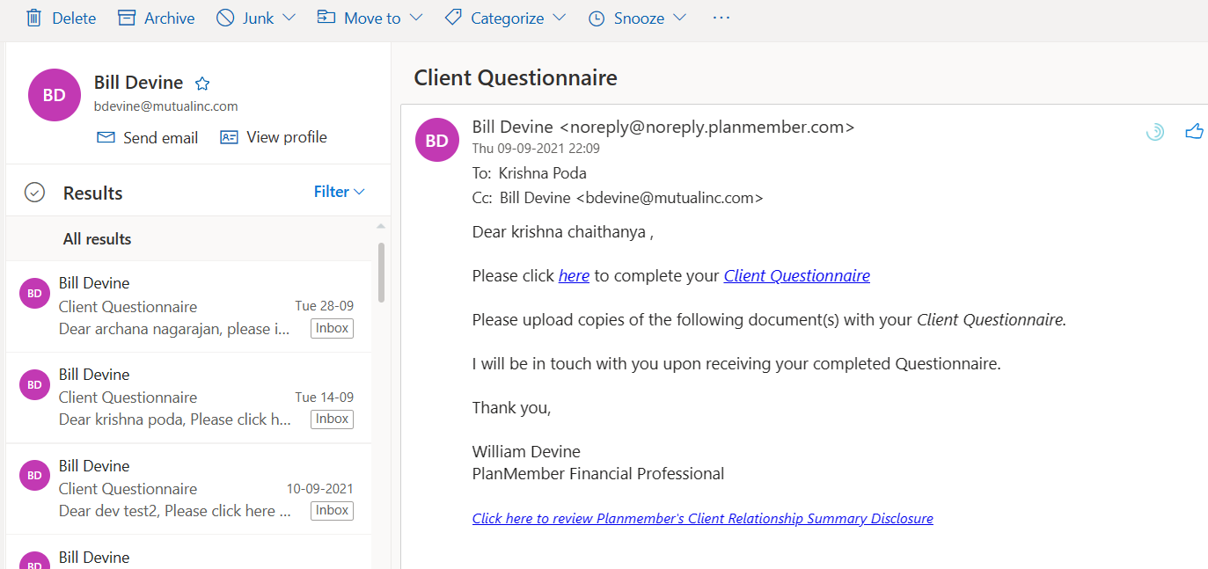

When client click on Client Questionnaire link, it will open Business connect temporary client page. We need to enter passcode and click on submit.

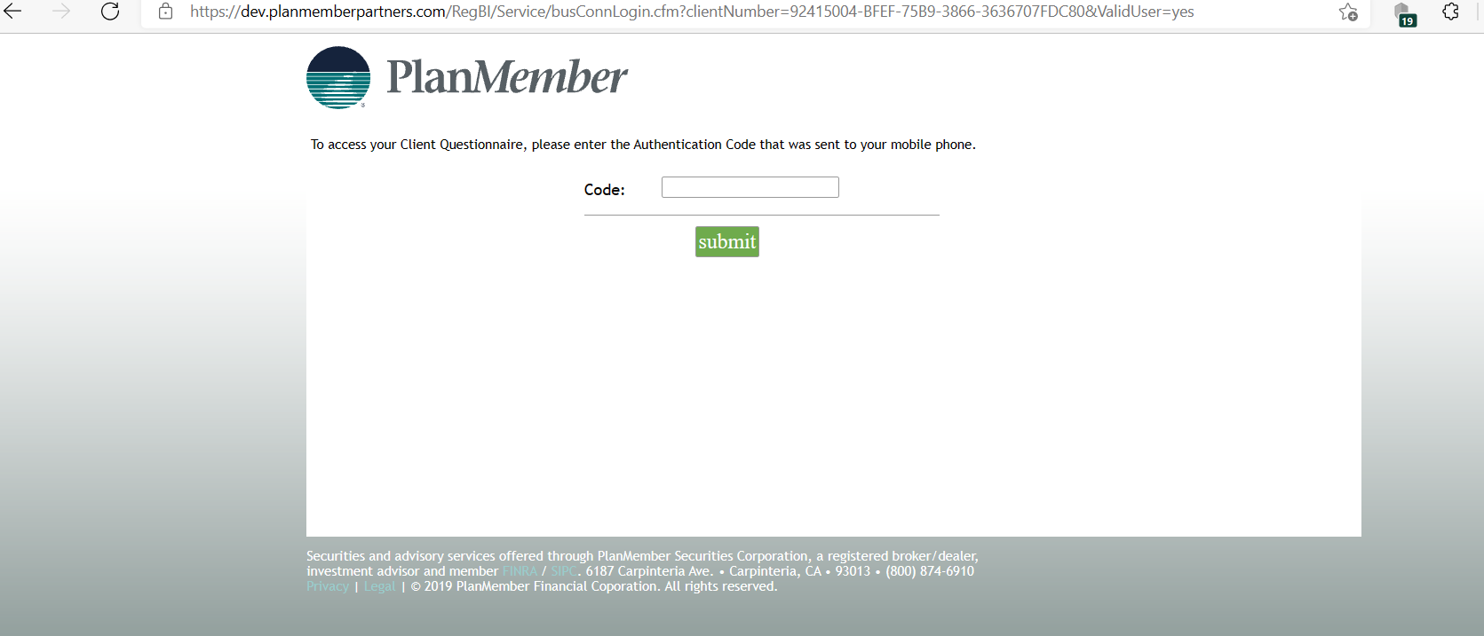

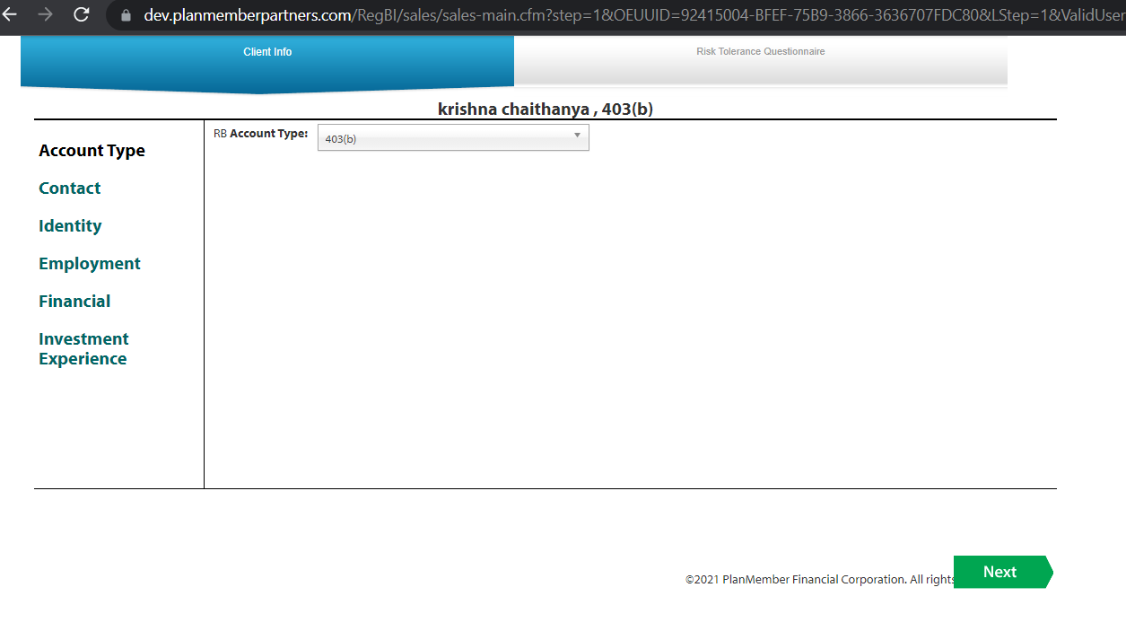

All the Client info details will be same as normal account.

Risk Tolerance Questionnaire: DB table – onlineenrollment.dbo.Clientinfo

If client answers all the questions and generated Investment objective, and rep added 10 products from his/her side for the same account, this RTQ answers effects for all 10 products.

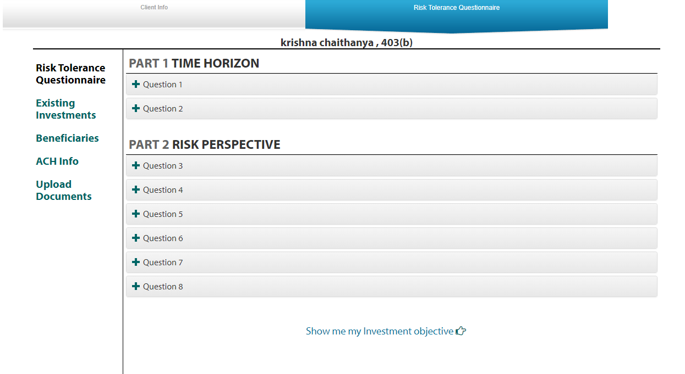

Existing Investments: DB table – onlineenrollment.dbo.Existingassets

Client will add his/her existing investments in this screen. we can add multiple investments.

The rep can see this existing investments in Rollover and he/she can create rollover with this details.

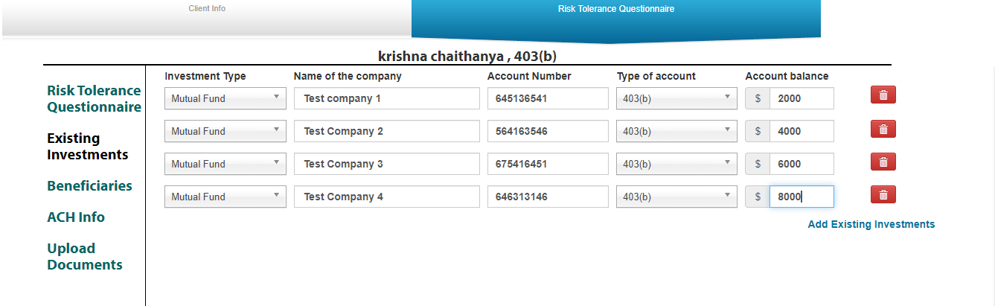

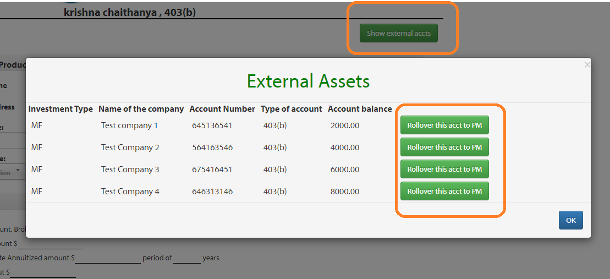

Upload Documents: DB table – onlineenrollment.dbo.fileupload

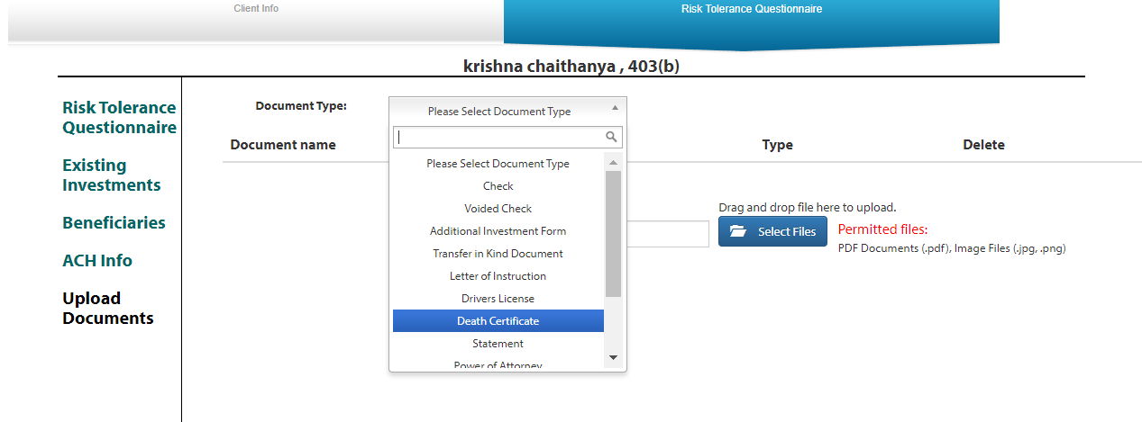

2.Open a New Account

We can use Business connect to create New account for clients. Based on Account types the rep can create new account for his/her clients.

We have different Account types:

Qualified Account types:

    "RB" = "403(b)" ,

    "RF" = "457" ,

    "RT" = "Roth 403(b)" ,

    "RU" = "Roth 457" ,

    "RJ" = "401a" ,

    "R7" = "Profit Sharing Plan" ,

"U2" = "Defined Benefit Plan" ,

    "U3" = "Optional Retirement Plan" ,

    "R6" = "401(k)" ,

    "R3" = "Defined Contribution Plan" ,

    "XE" = "Roth Solo 401 (k)" ,

    "XD" = "Solo 401 (k)"

Non Qualified Accounts :

    "XO" = "501C3 Charitable Organization" ,

    "529" = "529 Information" ,

    "ATND" = "Account Type Not Determined",

    "CO" = "Corporate" ,

"ES" = "Estate",

    "IN" = "Individual" ,

    "TD" = "Individual TOD" ,

    "RL" = "Inherited IRA" ,

    "RN" = "Inherited ROTH IRA" ,

    "R4" = "IRA" ,

    "R8" = "IRA" ,

    "XA" = "Joint Tenant TOD" ,

    "TC" = "Joint Tenants in Common",

    "TE" = "Joint Tenants in the Entirety",

    "JT" = "Joint Tenants with Rights of Survivorship" ,

    "PT" = "Partnership" ,

    "RR" = "Roth IRA" ,

  "R5" = "SEP IRA" ,

    "RS" = "Simple IRA" ,

 "TR" = "Trust" ,

    "UG" = "UGMA" ,

    "UT" = "UTMA",

    "XK" = "Conservatorship"

Based on Account types we will show some extra submenu under each sections.

Main menu :

Client Info,products,investment Details, Select program, Source of funds, additional information, summary, Generate Paperwork.

In above menu Select program will display based on the product what rep select in product page like investment is Mutual fund and product name is retirement select then we will display Select program in main menu.

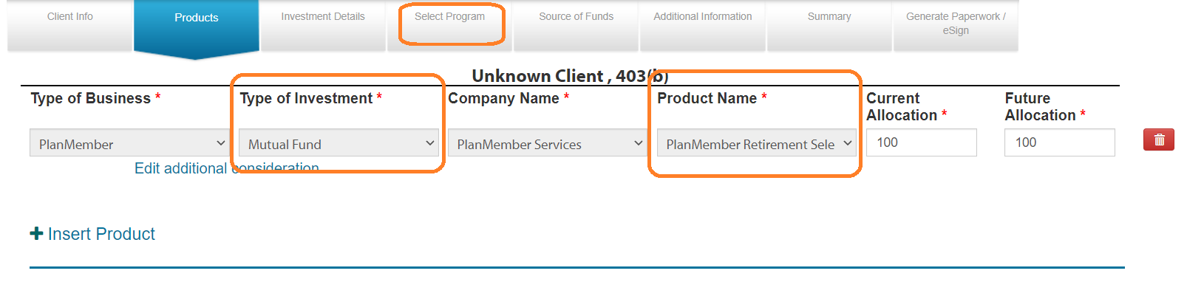

Code available in RegBi/Js/tab_nav.js – related to all on change functions like display/hide select program & source of funds for Work place advisory etc.

Code Related to left menu for every page available in RegBi/_Settings.cfm

Ex: For Client Info

Corporate : Trust:

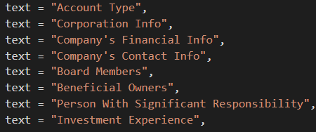 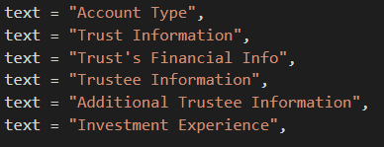

In Business connect the details of every page will save before come out of the page.(Ex: If we click on next button/ client on any other left menu link /click on any main menu link, It will save the data of the page)

Client Info :

Contact : DB Table OnlineEnrollment.dbo.ClientInfo

In contact page, SSN, Firstname,lastname,Email, Mobile Phone & Home address is mandetory fields

If home address & mailing address is different rep will provide mailing address.

If the client have POA(Power of Attorney) and when rep selects POA check box, then Rep will provide POA Details in contact page and Uploads POA Document.

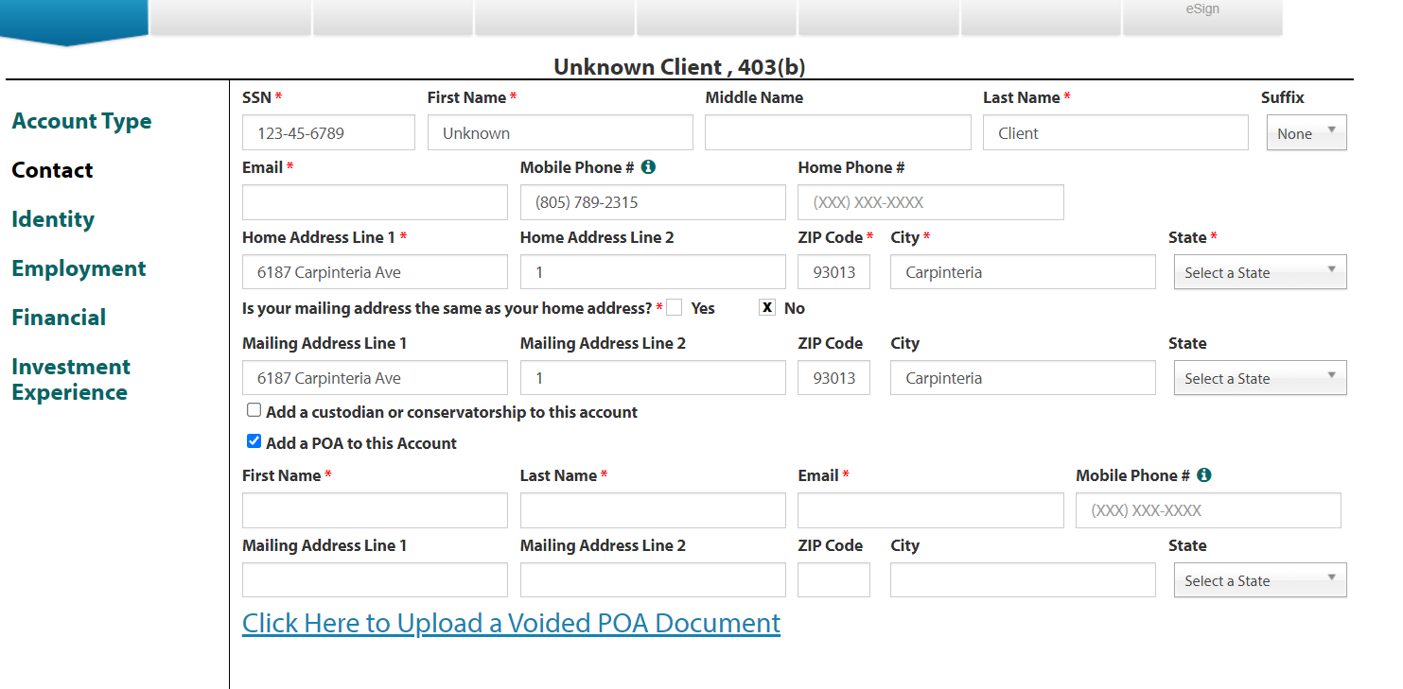

We can import existing data based on SSN.

When rep enters SSN, our program will check if any existing accounts available with SSN in Datawarehouse.

If it did not find any existing account in Datawarehouse, again it will check with OnlineEnrollment Business connect tables.

If Our program able to find existing accounts/ existing business connect data for SSN and it will import all data to out business connect table with new OEUUID.

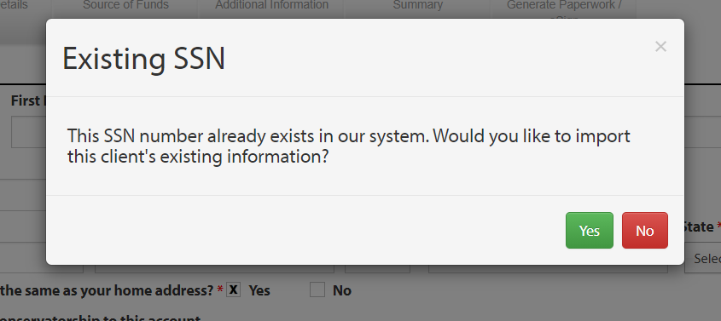

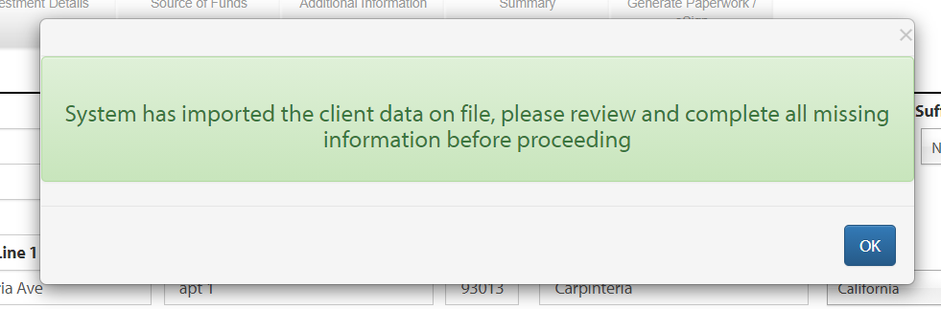

Identity: DB Table OnlineEnrollment.dbo.ClientInfo

In Identity screen we can get all Identification Details of Client.

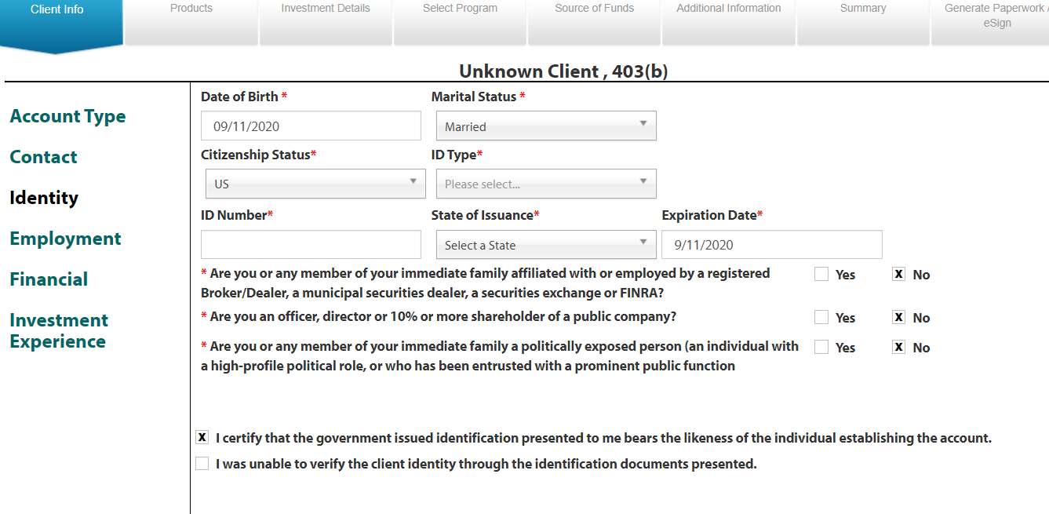

Employment: DB Table OnlineEnrollment.dbo.ClientInfo

In Employement screen we can get current Employer details of Client.

For account type SEP IRA we will get Employemnt document also

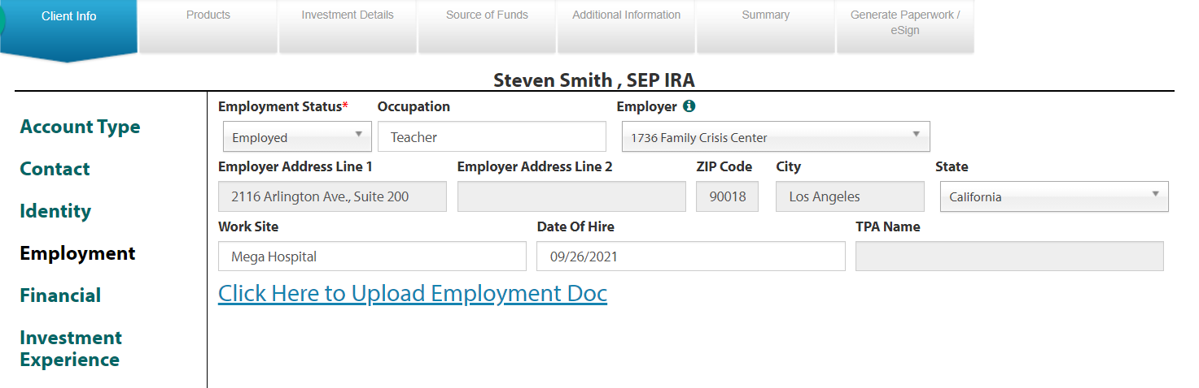

Financial: DB Table OnlineEnrollment.dbo.ClientInfo

In Financial screen we can get Client Financial Details. Here we have two rules

1. Liquid Networth should not be greater than networth
2. If rep filled special expences of cleint, they need to provide time frame for special expences also.

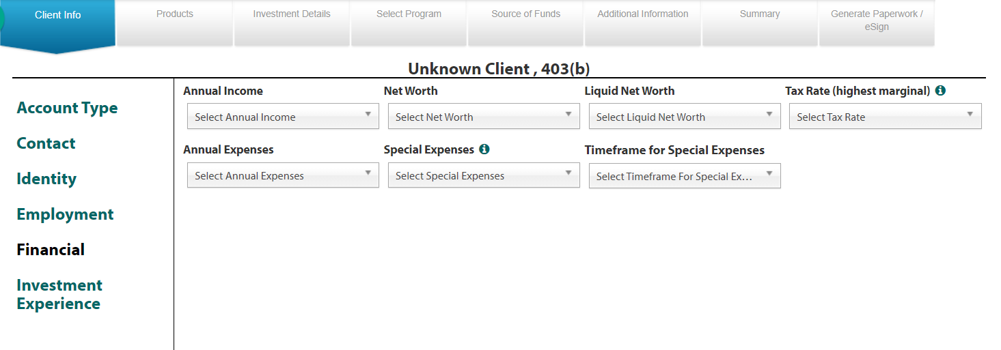

Investment Experience: DB Table Onlineenrollment.dbo. NASClientInvestor

In investment experience screen we will get the previous experience of investments like stocks, mutual funds.

1. After selecting years of experience check box, Amount field will enable to get the amount.
2. After we enter Amount, It will calculate approximate Allocation % based on total.
3. Total approximate Allocation should be 100 %

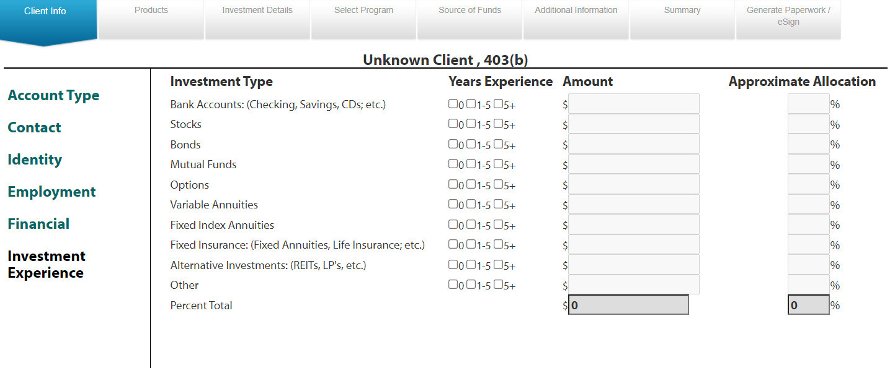

529/ABLE Information: DB Table Onlineenrollment.dbo. DeceasedInfo

For Account type 529 Information we are showing extra screen for 529 Information.

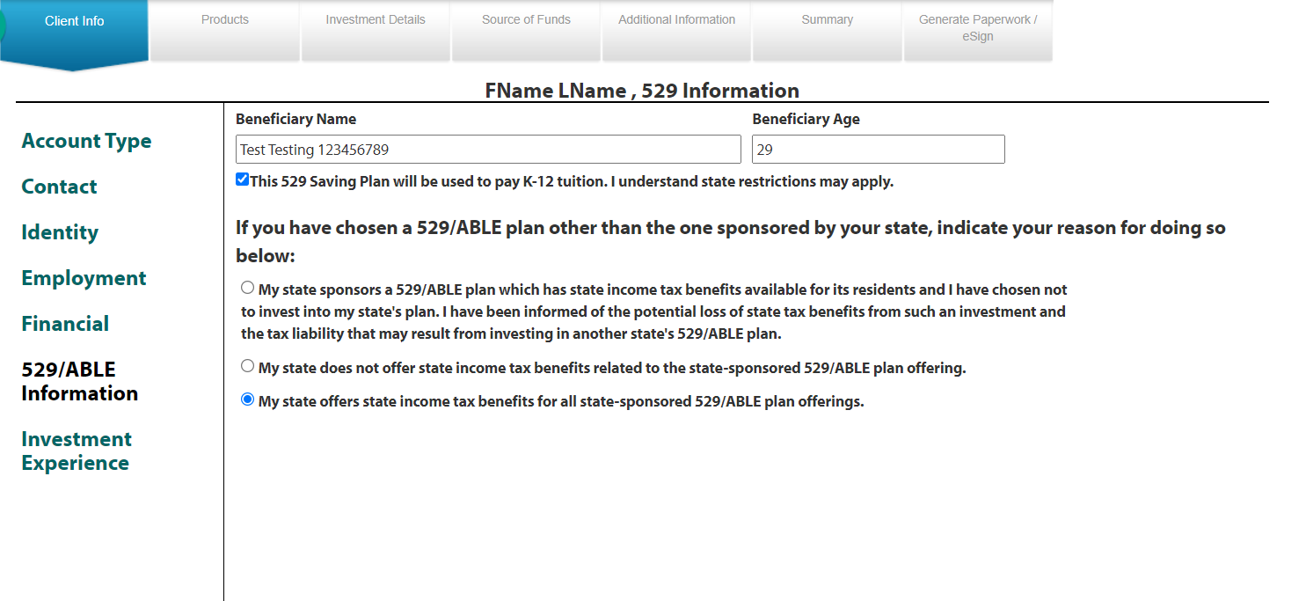

For account type Corporate , Partnership, Estate,501C3 Charitable Organization rep will provide below info

Corporation Info -- DB Table Onlineenrollment.dbo.DeceasedInfo

Corporation details.

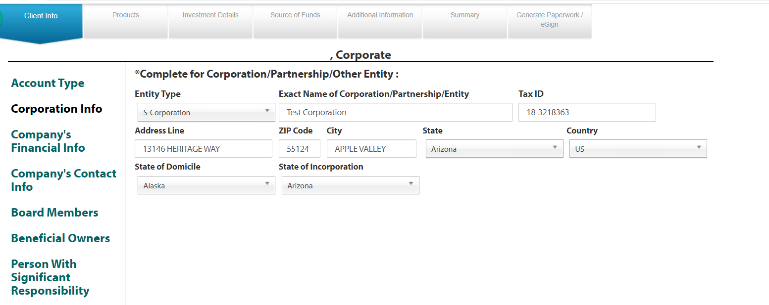

Board Members -- DB Table Onlineenrollment.dbo. CorporateBoardMembers

In Board Members it is like combination of contact, Identity,Employment.here we can add multiple Board Members.

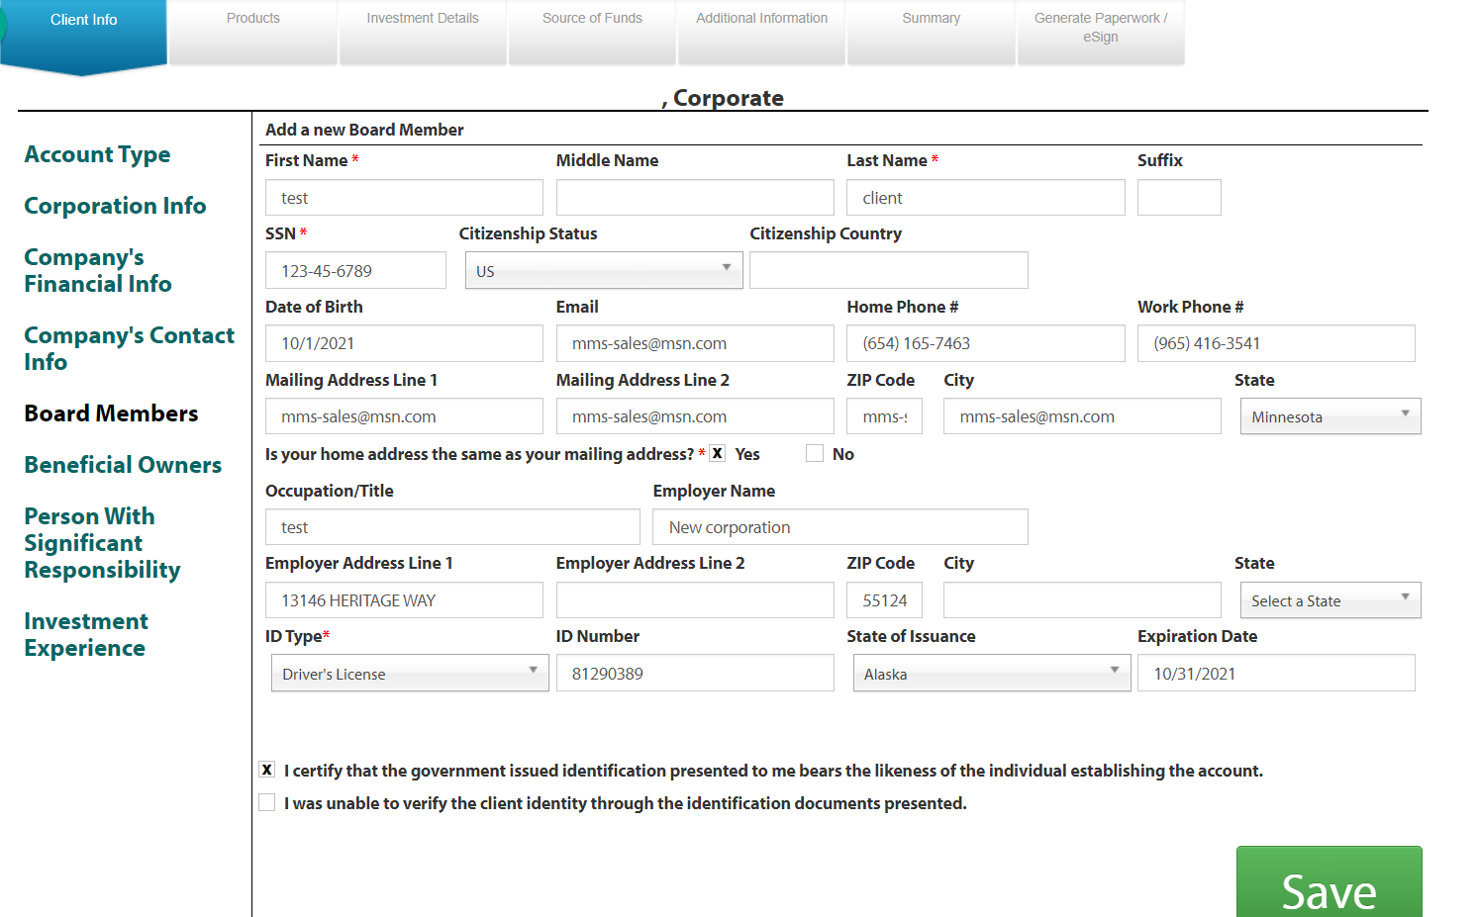

Beneficial Owners - DB Table Onlineenrollment.dbo. CorporateBeneficialOwners

We can add multiple Beneficial Owners.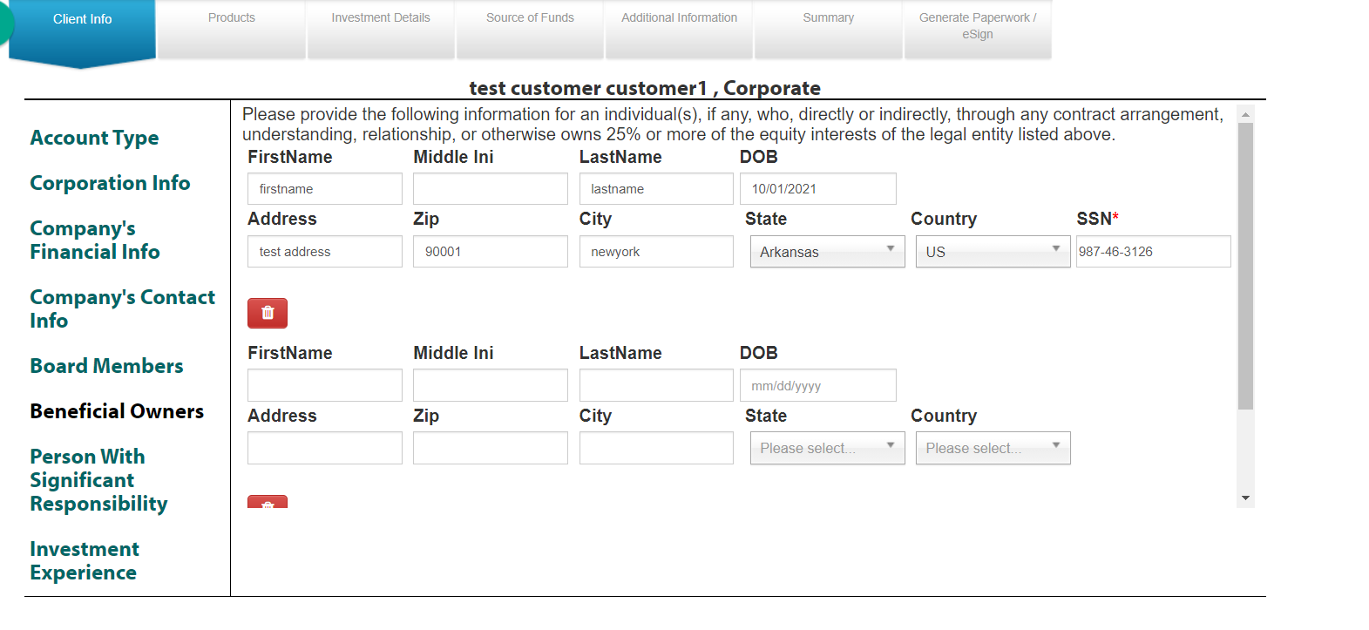

Person With Significant Responsibility - DB Table Onlineenrollment.dbo.CorporateBeneficialOwners

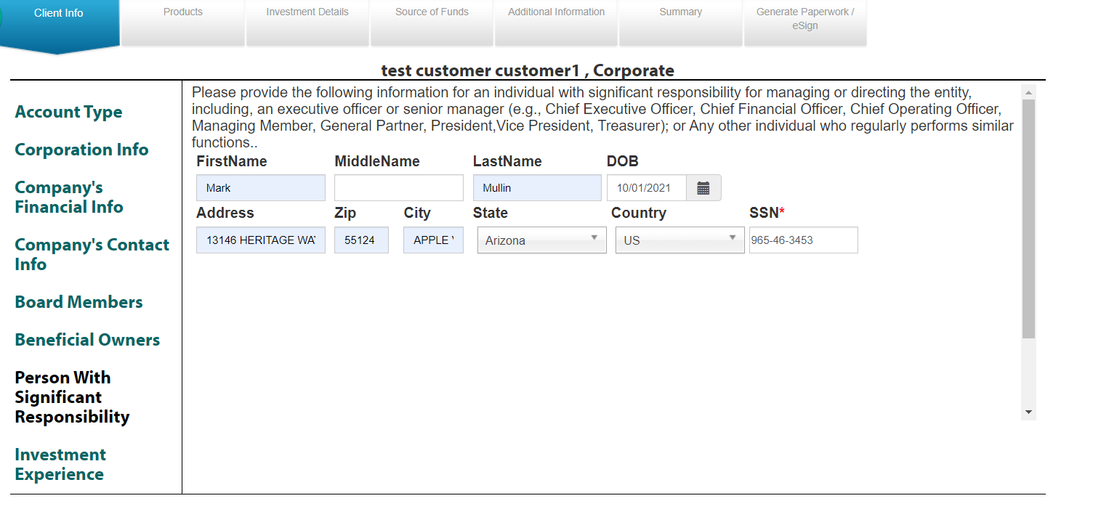

### For account type Joint Tenant TOD, Joint Tenants in Common, Joint Tenants in the Entirety, Joint Tenants with Rights of Survivorship

rep will provide below info extra

Joint Client Info - DB Table Onlineenrollment.dbo.JointclientInfo

Joint Client info is like combination of contact, Identity,Employment.

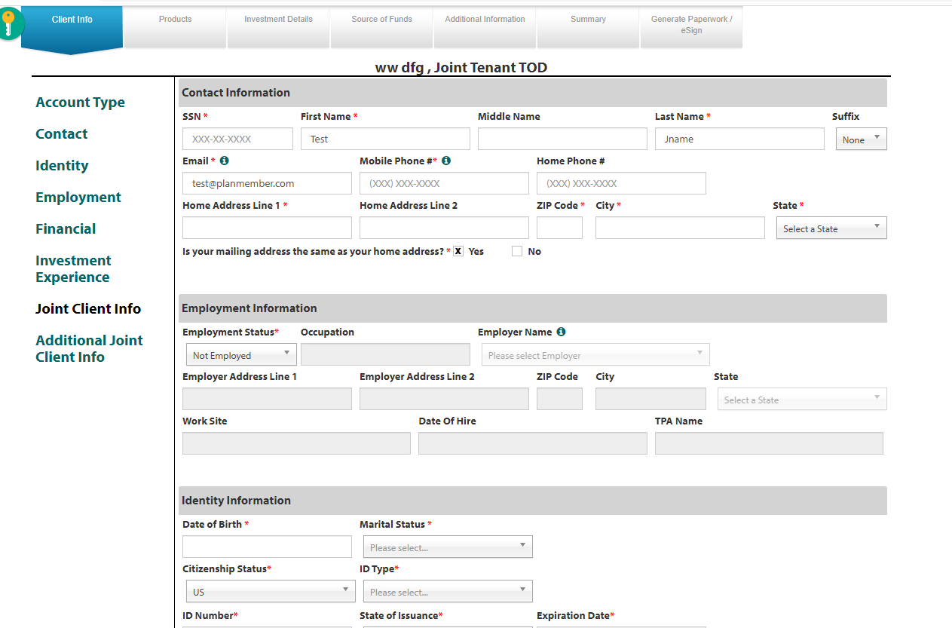

Additional Joint Client Info - DB Table Onlineenrollment.dbo. AddlJointclientInfo

Additional Joint Client info is like combination of contact, Identity,Employment.

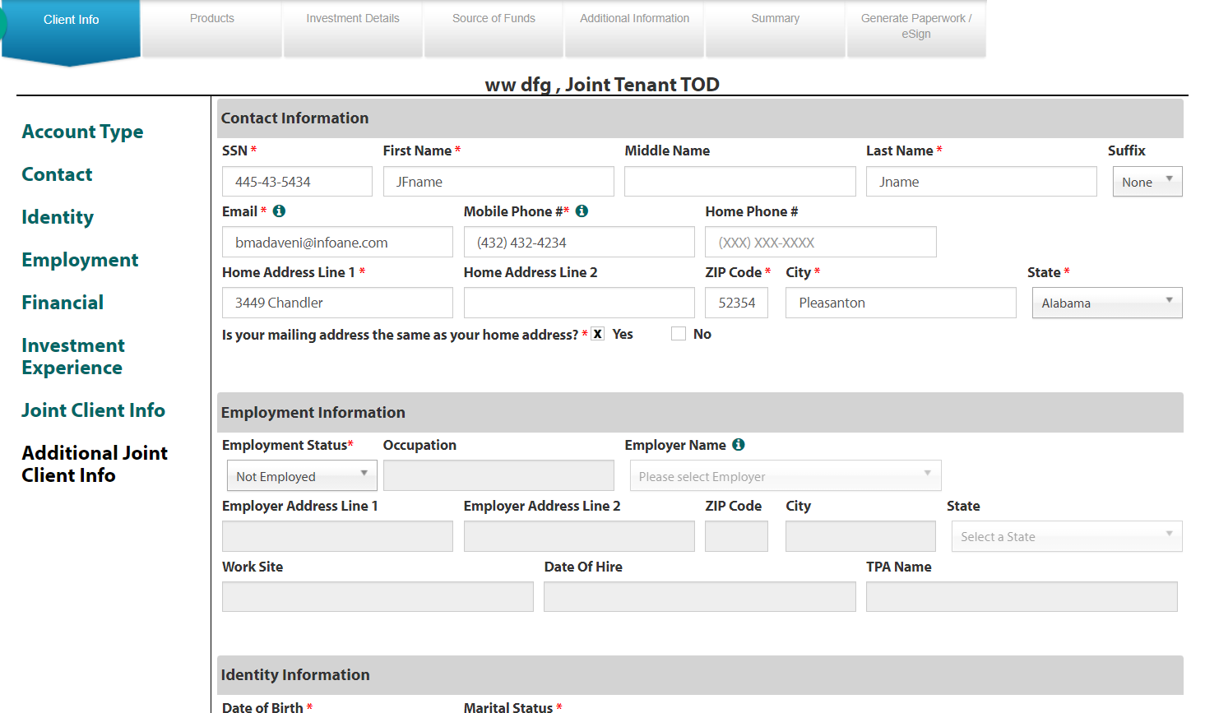

### For account type Trust

rep will provide below info extra

Trust Information - DB Table Onlineenrollment.dbo.DeceasedInfo

Trust Info will have all the trust details. Here we will get trust document also.

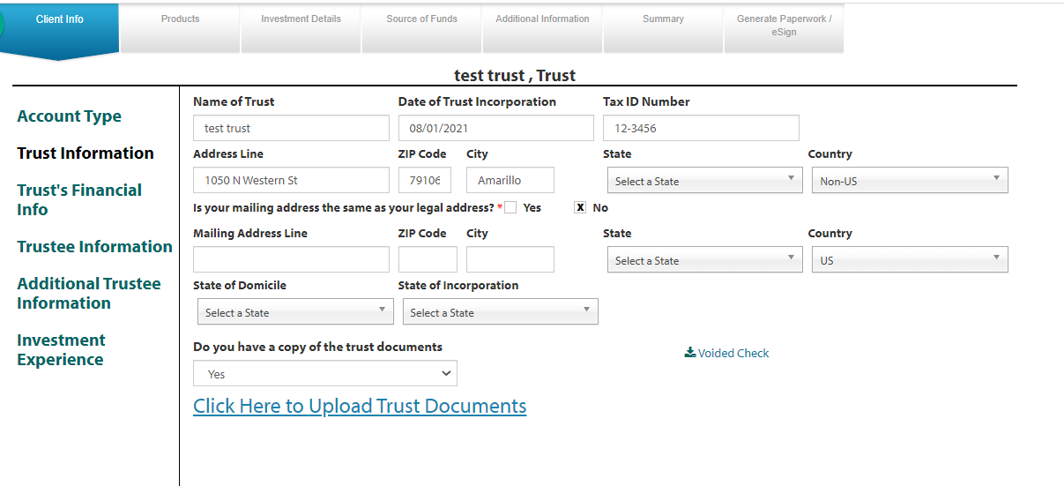

Trustee Information - DB Table Onlineenrollment.dbo.ClientInfo

Trustee info is like combination of contact, Identity,Employment. It is Normal Client Info Related to trust. We will save this data into Cleintinfo table only.

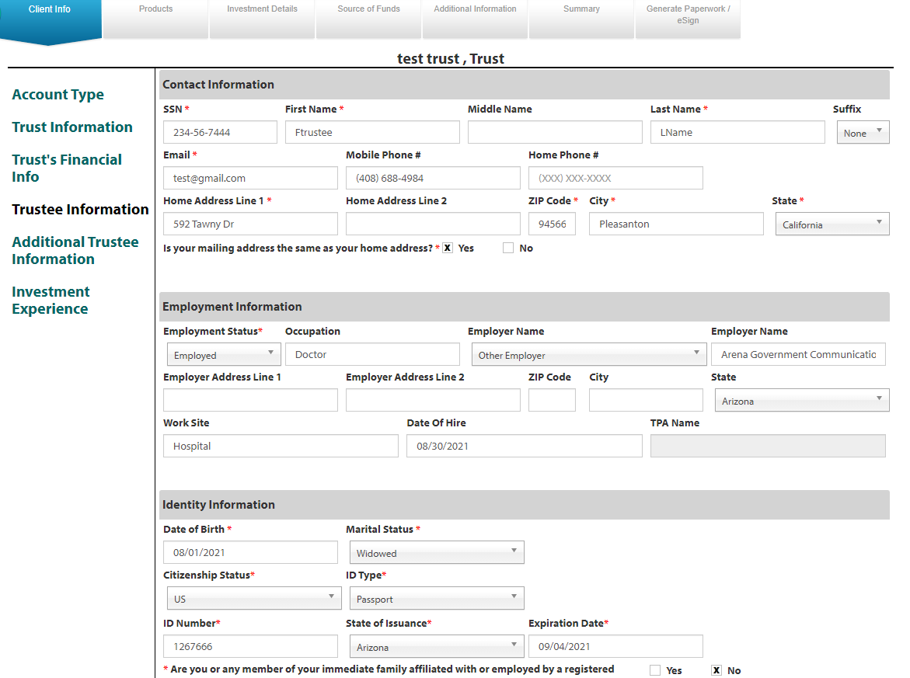

Additional Trustee Information - DB Table Onlineenrollment.dbo.TrustAdditionalInfo

Additional Trustee info is like combination of contact, Identity,Employment. It is Additional Client Info Related to trust. We will save this data into trustAdditionalInfo table.

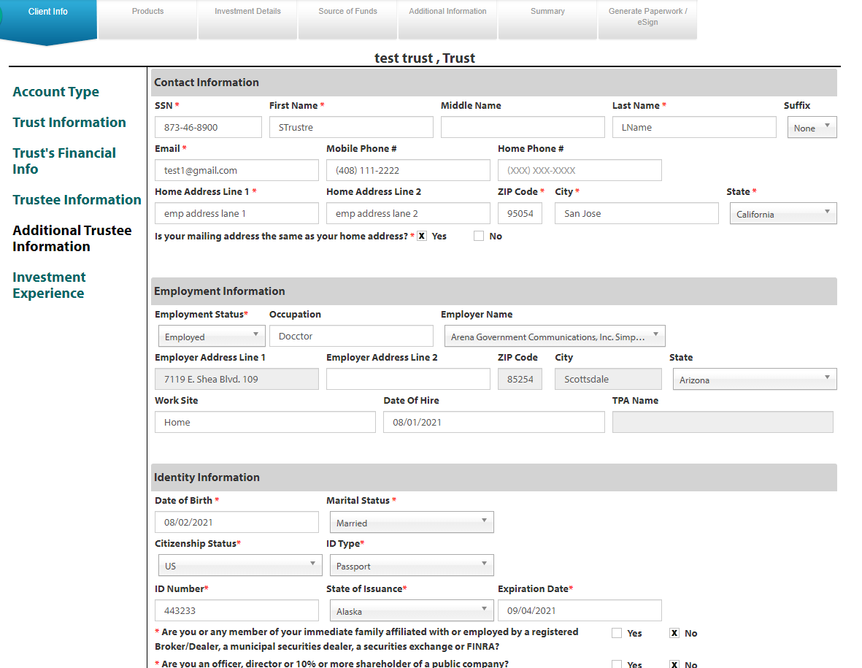

### For account type Inherited IRA

rep will provide below info extra

Deceased person- DB Table Onlineenrollment.dbo.DeceasedInfo

Deceased person will have details of deceased person. Here we will get deceased document also.

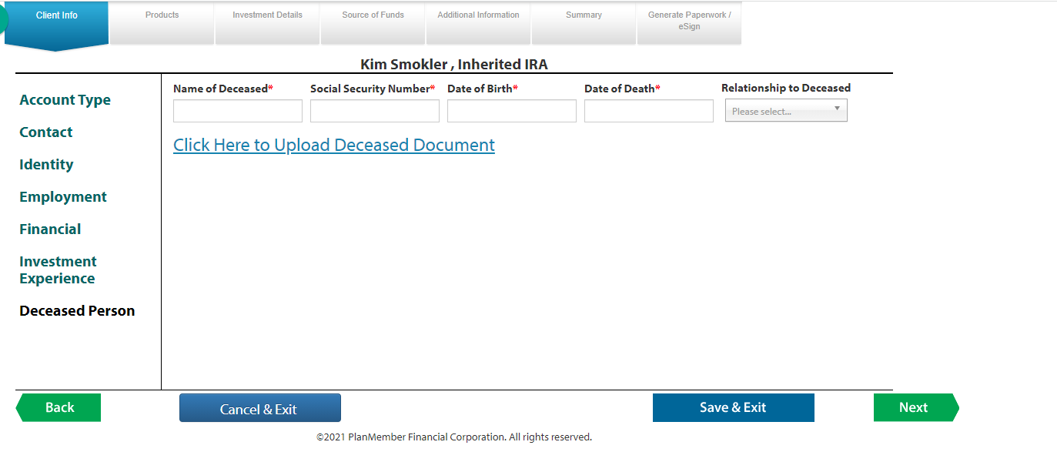

### For account type UTMA/UGMA

rep will provide below info extra

Minor Info- DB Table Onlineenrollment.dbo.DeceasedInfo

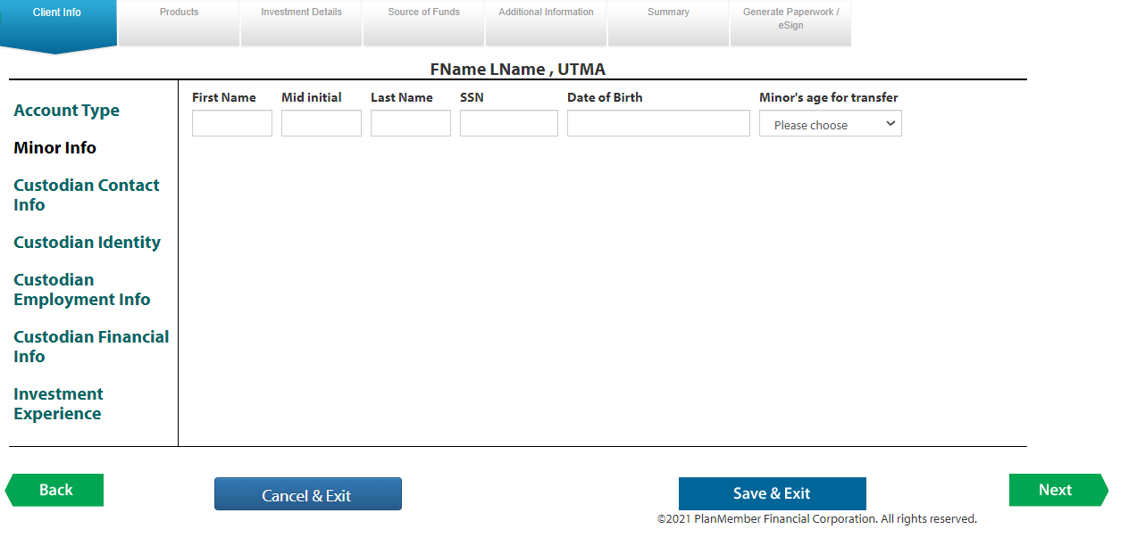

Products- DB Table Onlineenrollment.dbo.NasTargetproductdetails

To select products we will use products section.Here we can add multiple products.

Once we click on Insert product, First we will show type of business, after selection of type of business,based on selection will diplsy type of investment.

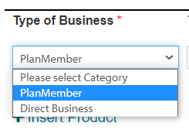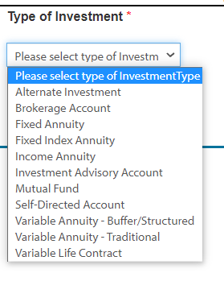

After Selecting Investment type, It will ask some investment considerations based on investment type.

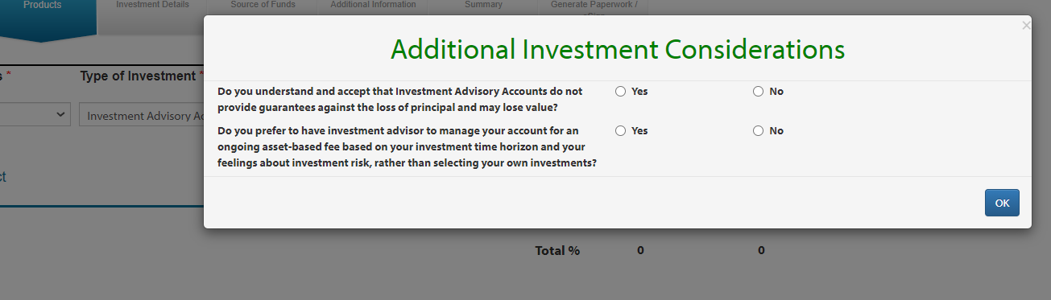

*When we choose Yes for all questions, our program will display companies & products based on selected investment type.*

*If we have Plan member services in company list, by default it will select plan member services as company and display products also*

*If we don’t have plan member services in company list, after selection of company, we will display products based on selected company.*

Once we select products it will ask for current and future allocations.

The total of current & future allocations should be 100. Ex if we add 2 products, the total current & future allocations should not more than 100.

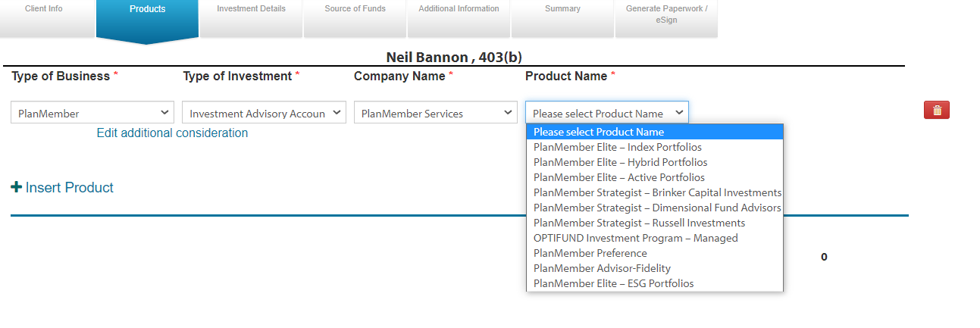

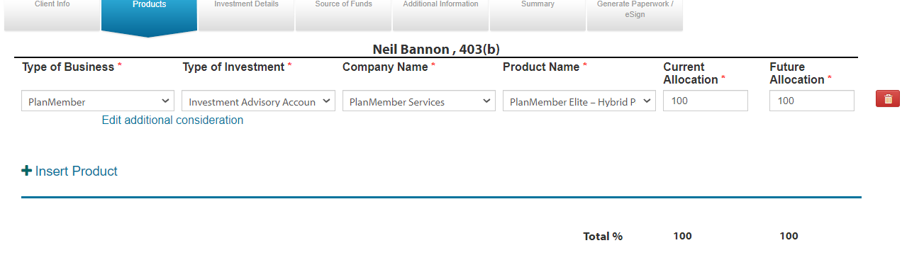

If we select plan member – work place advisory, it will ask for providers (not products) for work place advisory.

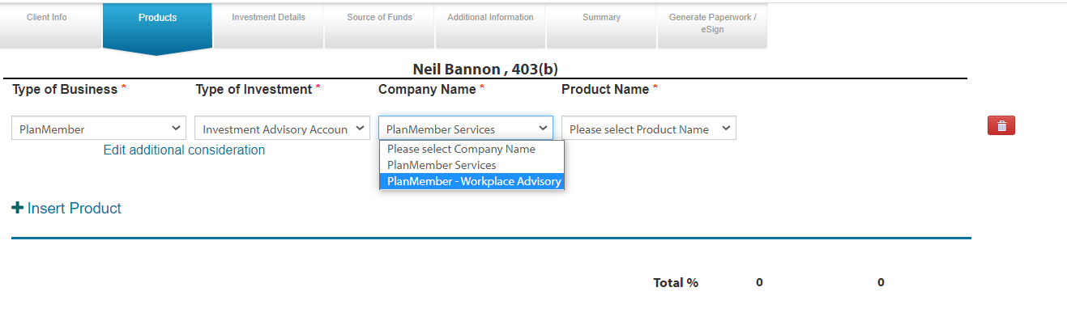

If the selected employer doesn’t have access to work place advisory products, it will ask for change the employer and redirect to employer screen.

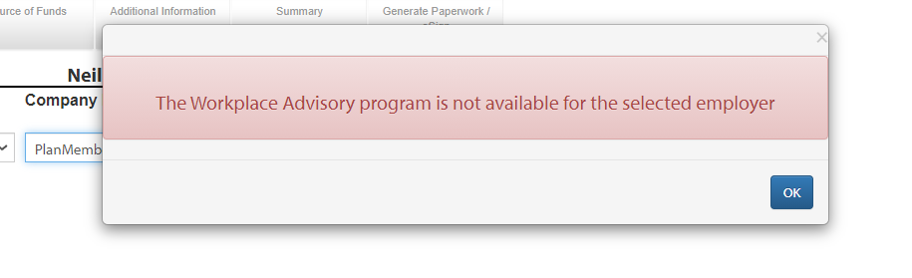

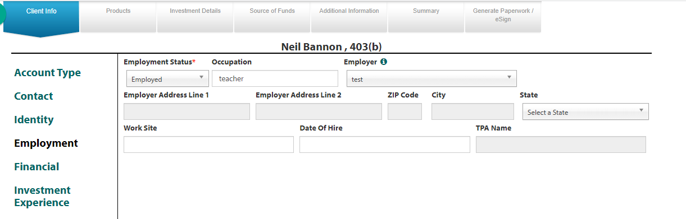

When we are adding multiple products, if any product not matching with others, we will not allow that in product page.

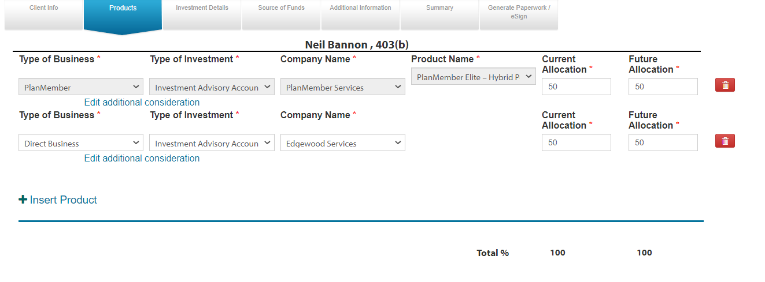

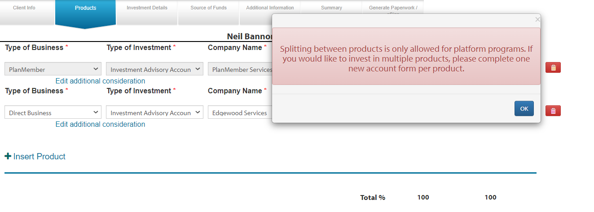

Investment types: all investment types will come from onlineenrollment.dbo.RegBIProductDetails

*Company: Company from* planmemberShared.dbo.PSECSellingList

Products: products from onlineenrollment.dbo.RegBIProductDetails *based on* Account type*.*

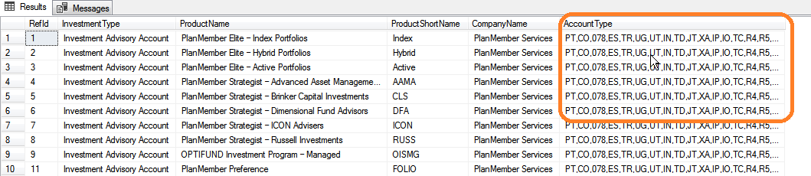

Investment Details- DB Table Onlineenrollment.dbo.NasTargetproductdetails

*We will provide RTQ, Additional product details in Investment Details. All details will save in Nastargetproductdetails.*

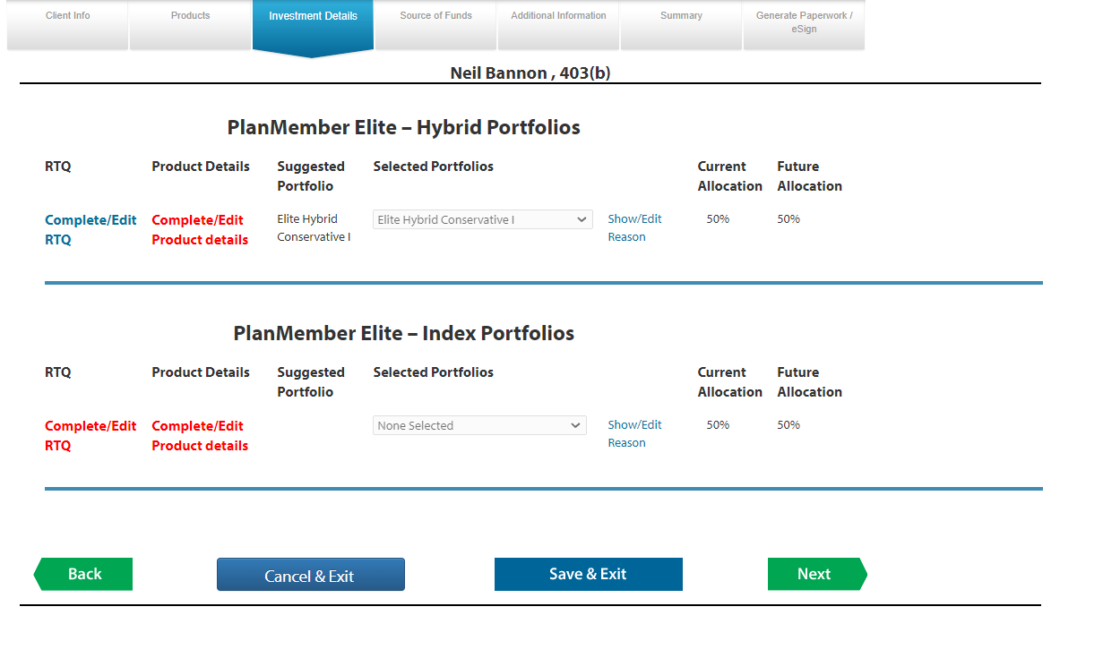

In RTQ, Rep will provide answers for the static questions. Every answer will have some score. Based on total score of all 8 questions it will calculate investment objective.

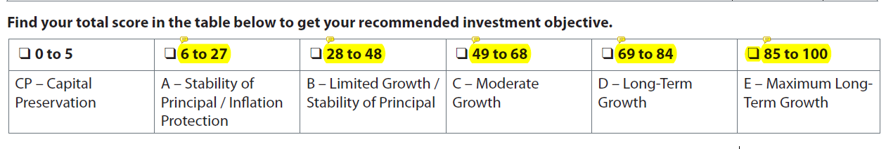

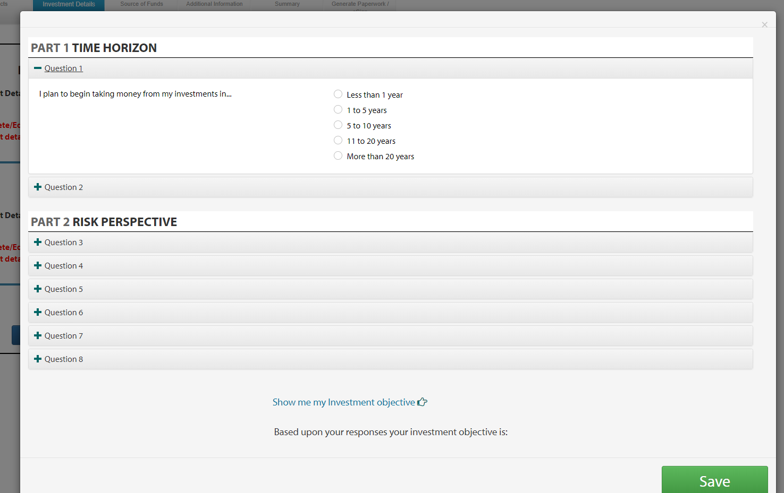

In Additional product details, we will provide some extra details for the product.

Based on product, this screen will display/hide some extra details.

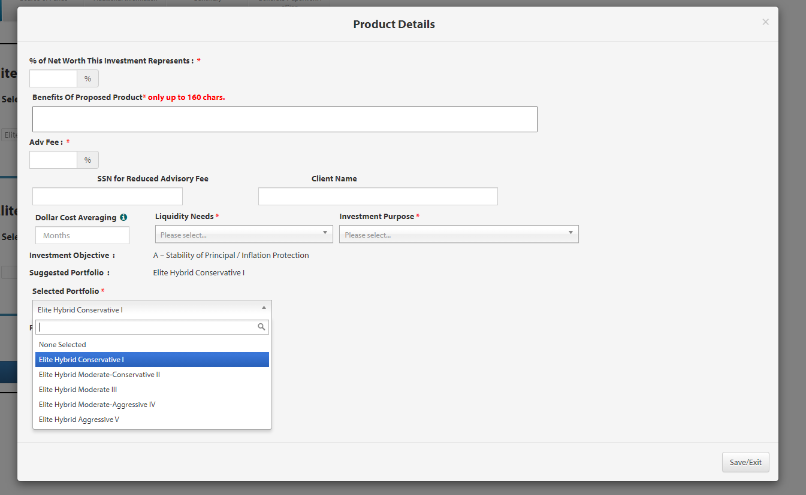

*If selected portfolio is not matching with suggested portfolio, we need to provide reason why we change the selected portfolio.*

*If we miss any required fields, it will display error message which is missing in additional product details.*

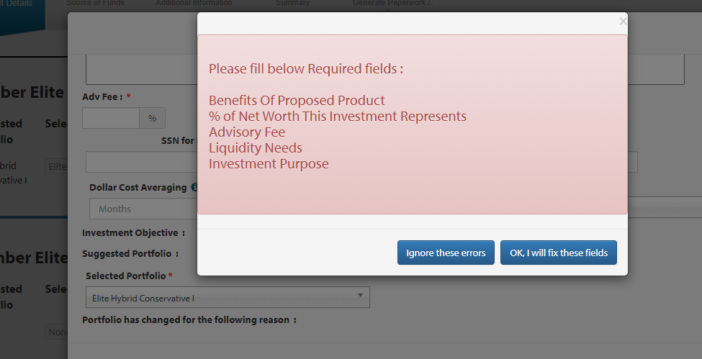

Select Program:

If the product is select program, we will display Select Program tab in menu

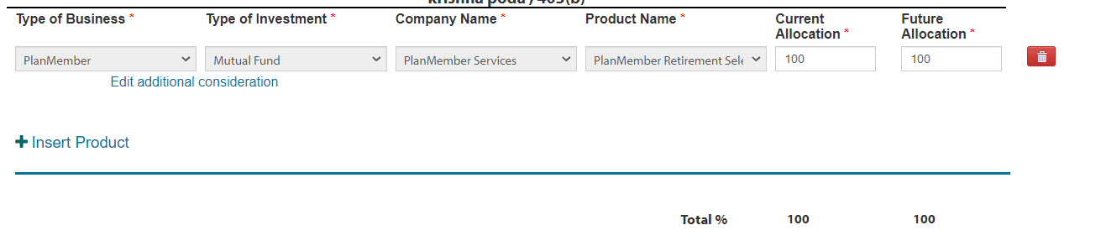

Reduced Sales Charges: DB Table - Onlineenrollment.dbo.accountinfo

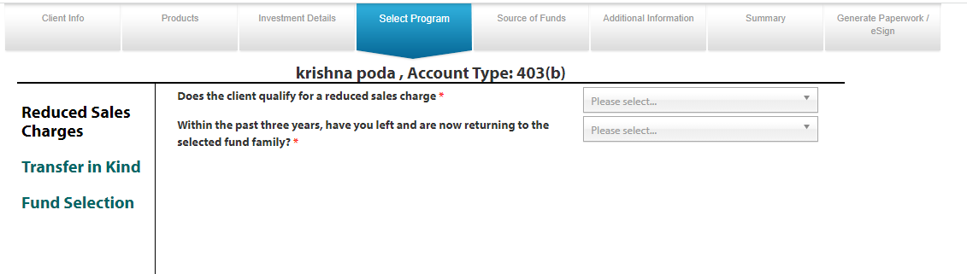

Transfer in Kind: DB Table – Onlineenrollment.dbo.Transferinkind

*In Transfer in Kind screen we can add multiple Tickers. when we try to add ticker symbol , it will automatically display options to select the correct ticker symbol.*

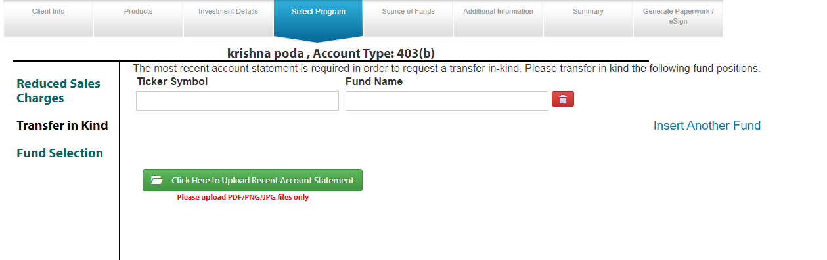

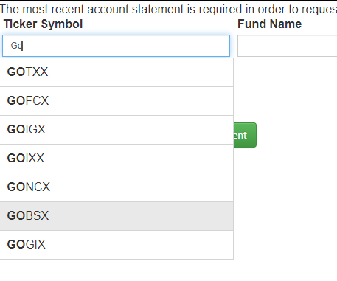

Once we select Ticker Symbol, it will automatically fill the Fund name based on selected Ticker Symbol.

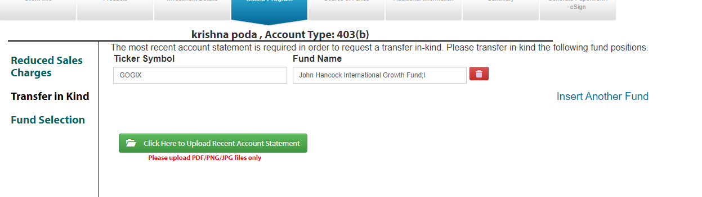

*We can multiple Tickers by clicking* Insert Another Fund.

Fund Selection: DB table – Onlineenrollment.dbo.FundAllocation

Fund selection to select funds and percentage. It will redirect to planmember.com *and include fund selection page in business connect frame.*

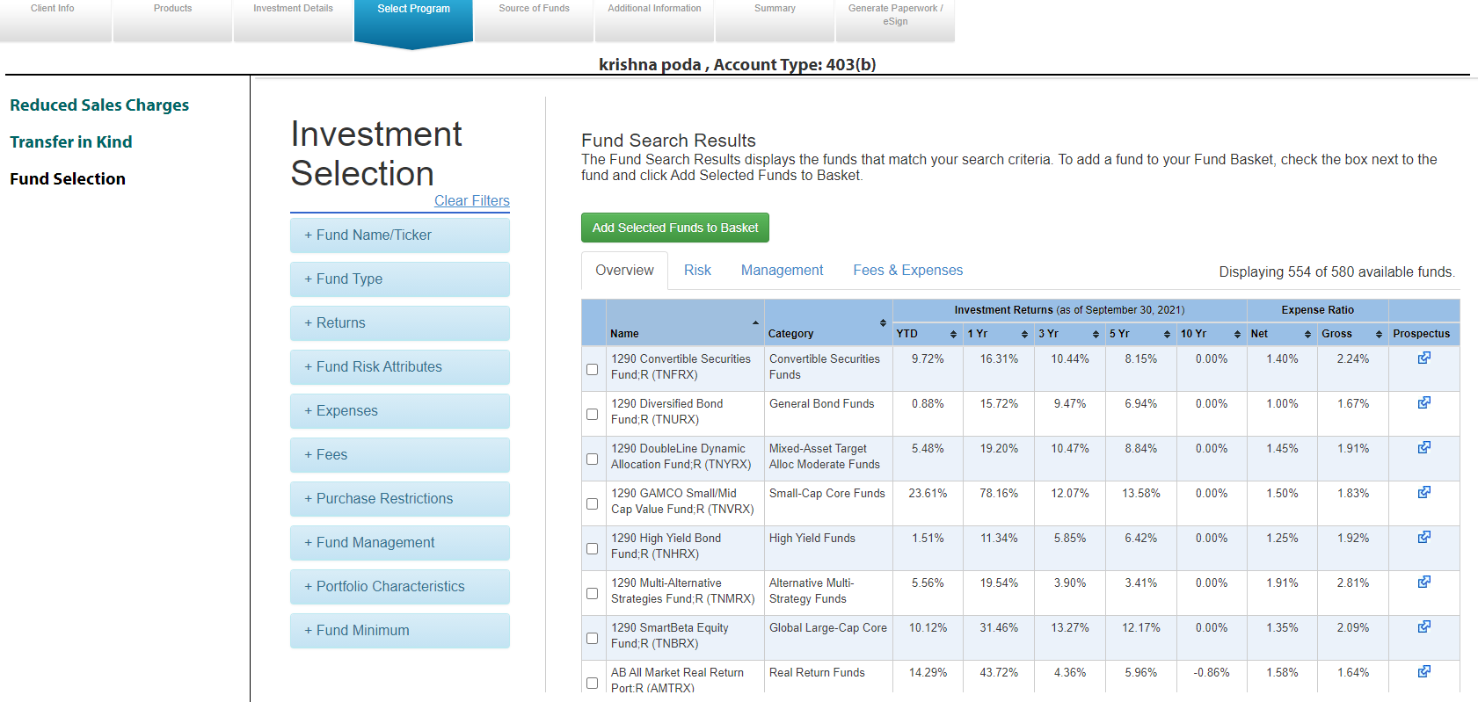

Once we select funds by checking the check boxes and click on add selected funds to Basket, it will show selected funds in basket and we can add percentage & sales charge to selected funds.

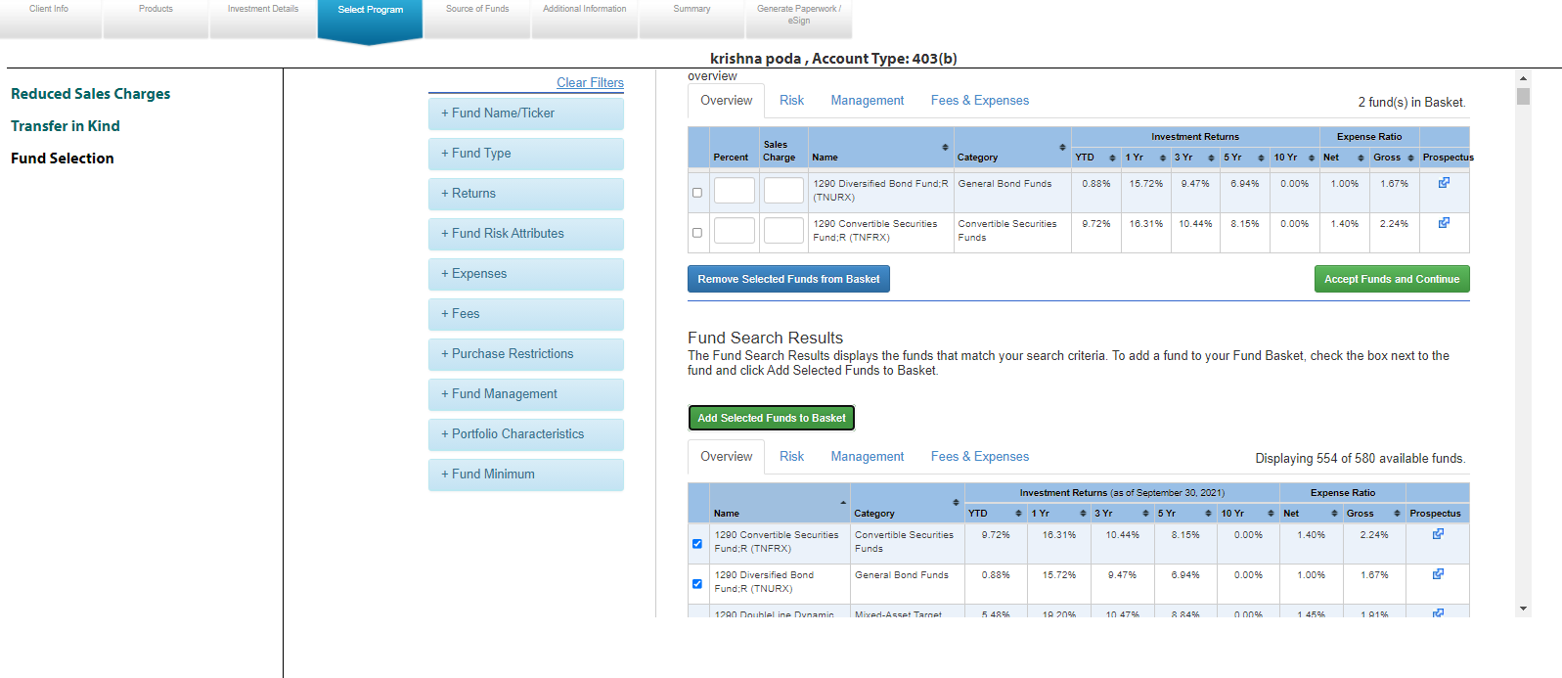

*After adding percentage (Total percentage of all funds should be 100) and sales charge, if we click on accept funds and continue.it will redirect from* planmember.com to business connect and goes to source of funds screen

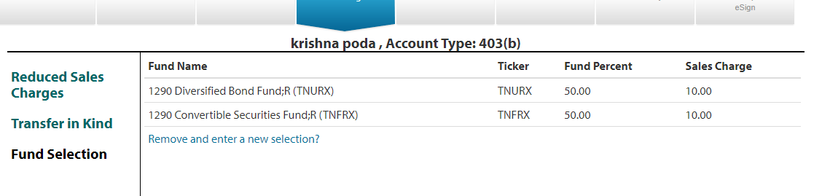

Source Of Funds:

RollOver/transfer/Exchange: DB Table Onlineenrollment.dbo.Rollover

In Rollover, we can add multiple rollovers for the existing accounts.

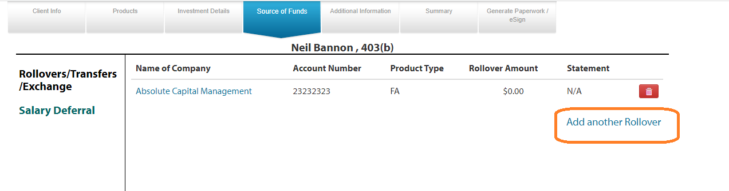

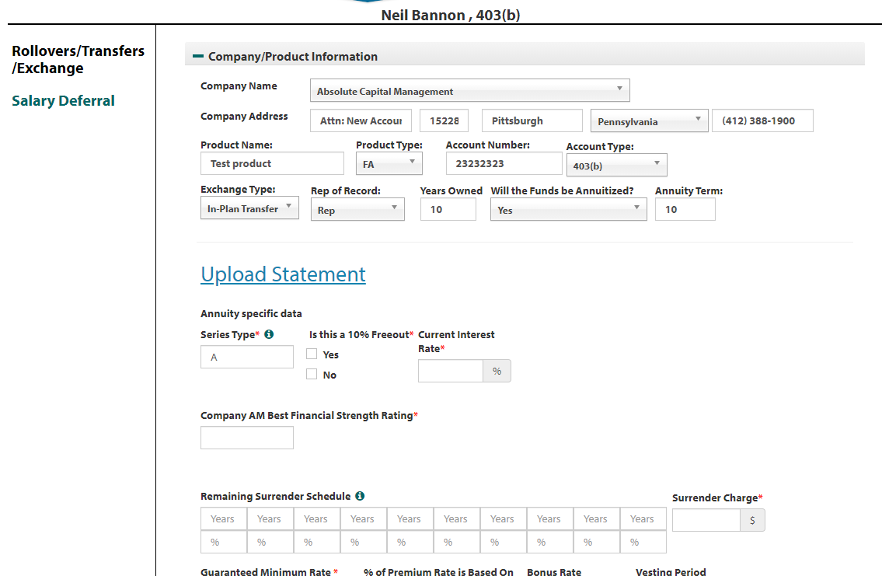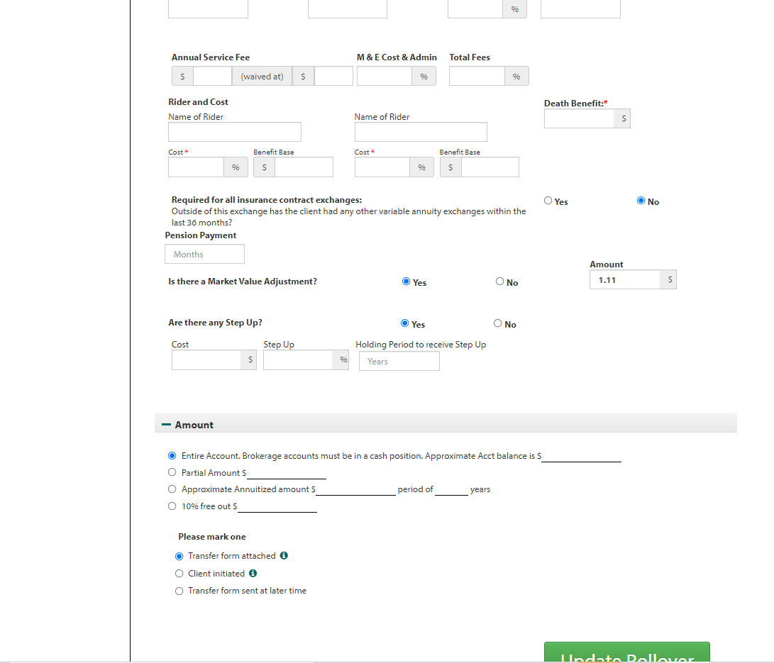

*In above screen shot based on product type what we select in top of the screen, it will show additional details (like additional product details in investment details).*

*We can upload a document related to Rollover statement.*

*Last, we will mention partial/full amount which we will transfer from selected account in rollover.*

Salary deferral: DB table - onlineenrollment.dbo.salarydeferral

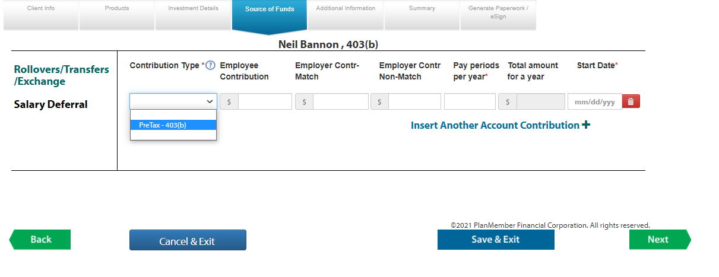

In salary deferral, we will provide contribution type, employee contribution, employer contribution,employercontribution Non-match,pay periods & start date.

We will ask salary deferral for below account types

403(b), 401a, Profit Sharing Plan, Optional Retirement Plan, Defined Benefit Plan, 401(k), Defined Contribution Plan, 457, Roth 403(b), Roth 457, Roth Solo 401 (k), Solo 401 (k), SEP IRA, Simple IRA, 501C3 Charitable Organization, 529 Information, Corporate, Estate, Individual, Individual TOD, Joint Tenant TOD, Joint Tenants in Common, Joint Tenants in the Entirety, Joint Tenants with Rights of Survivorship, Partnership, Trust, UGMA, UTMA, Conservatorship

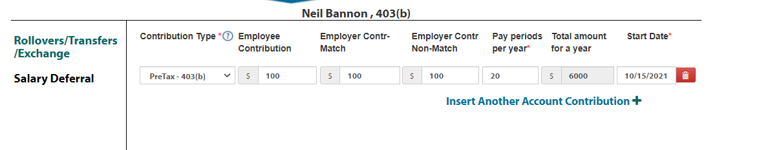

*Salary deferral not available for all the employers. If the selected employer not eligible for salary deferral, program will display error message and when we click on ok, it will redirect to employment screen to change the employer.*

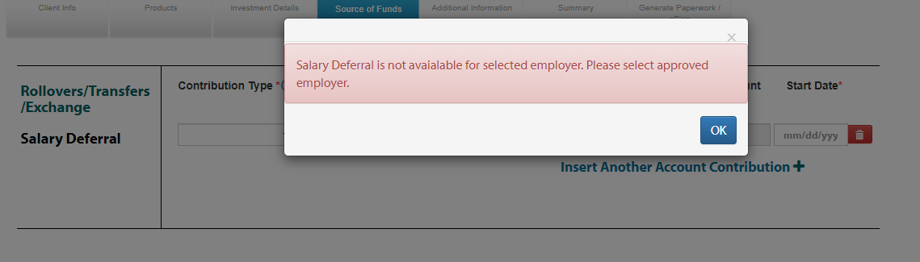

We can add max 2 salary deferral (pre tax, post tax).

For SEP IRA,Simple IRA, we are asking for employer contribution,pay periods and start date only.

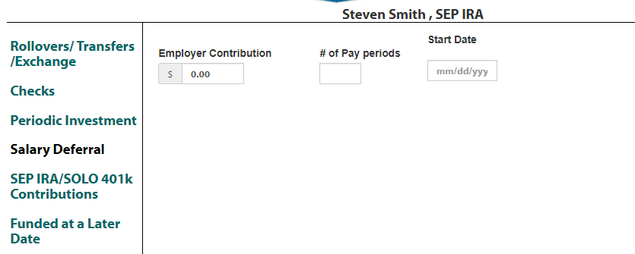

For all Non qualified account types , we will ask for checks, periodic Investment.

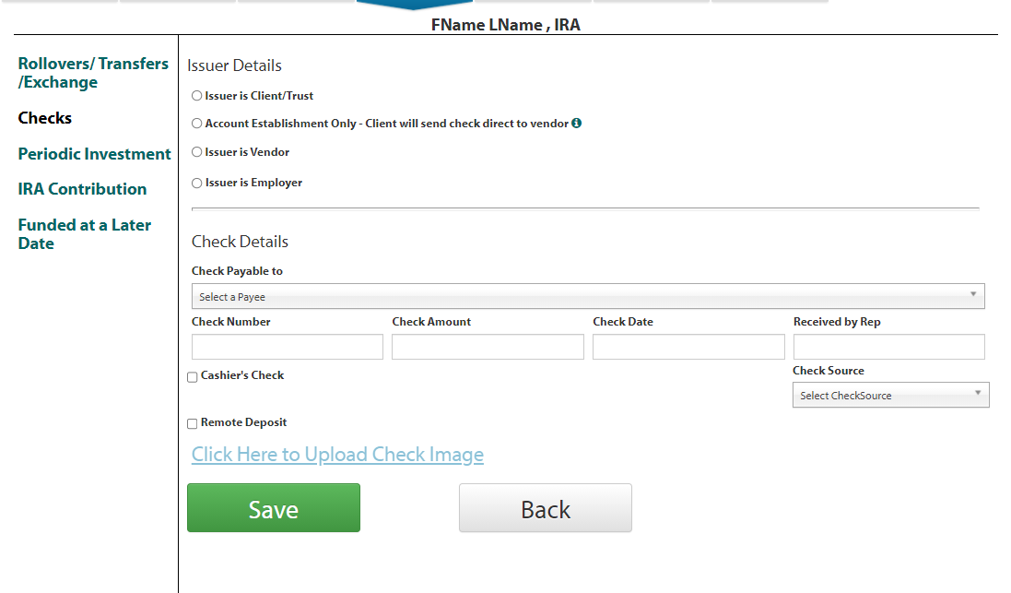

*In check screen, we can add multiple checks.*

*We have one relation from rollover to checks. In check screen if we select issuer is vendor, it will ask for rollover relation.*

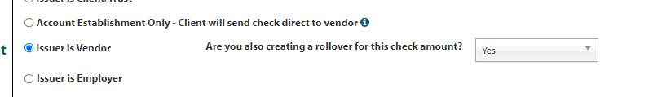

In the same time, in rollover if we selected Client initiated-check Enclosed, we will ask for check number and check amount.

We have validation for this in check screen and rollover screen.

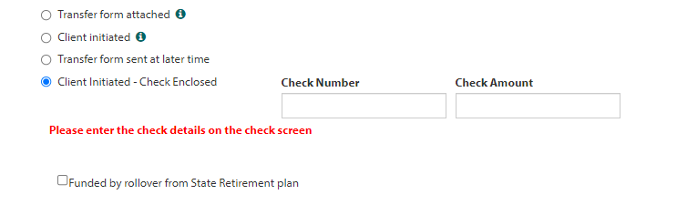

Periodic Investment: DB table – Onlineenrollment.dbo.salarydeferral

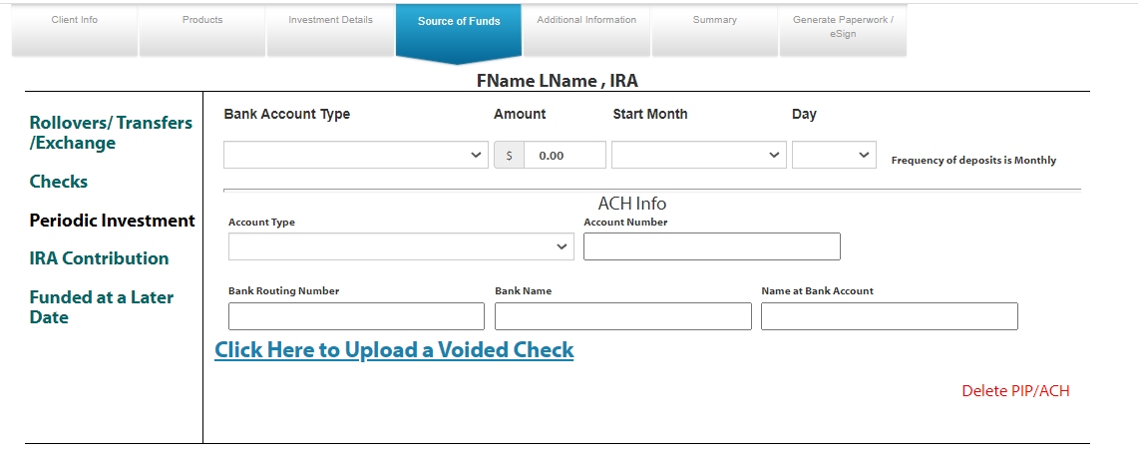

For all IRA Account we will ask for IRA Contribution & Funded at later date.

IRA Contribution: DB table – Onlineenrollment.dbo.ClientInfo

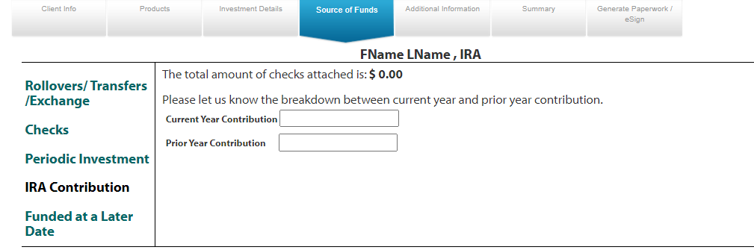

Funded at a later date: DB table – Onlineenrollment.dbo.clientInfo

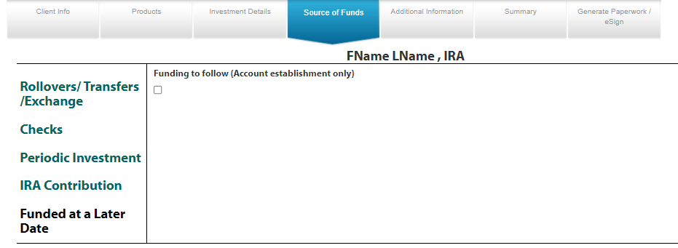

For SEP IRA, Solo 401(k) & Roth Solo 401(k) we will ask for SEP IRA/Solo 401k Contributions.

[SEP IRA/SOLO 401k Contributions](https://dev.planmemberpartners.com/RegBI/sales/sales-main.cfm?step=5&OEUUID=BACEDB04-FFC1-B0ED-9693-152AC6AC46FD&LStep=5" \o "SEP IRA/SOLO 401k Contributions)

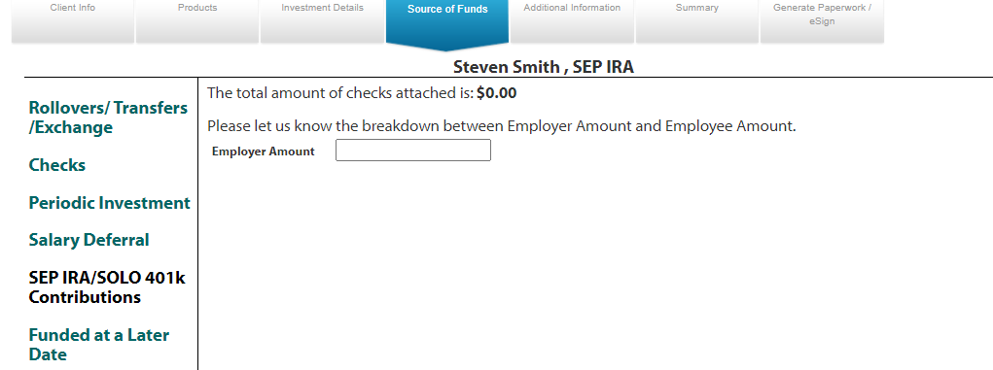

Additional Information:

Benefits

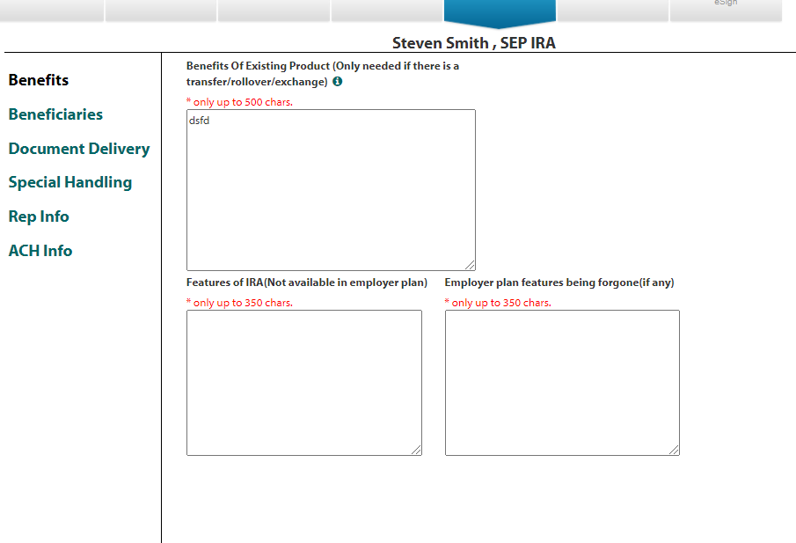

Beneficiaries

We can add multiple primary & contingent Beneficiaries and Total percent should be 100 only.

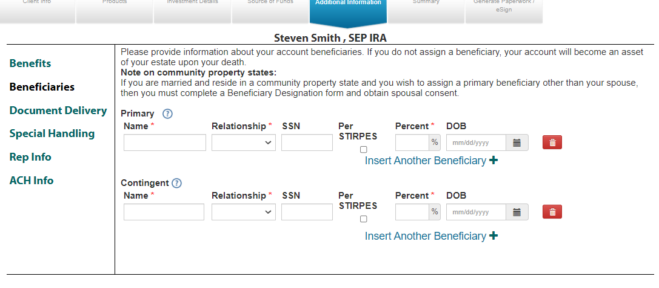

Document delivery

By default, it will select Electronic to send the documents for Esign. For some reason if rep wants to send the documents manually, they will select paper.

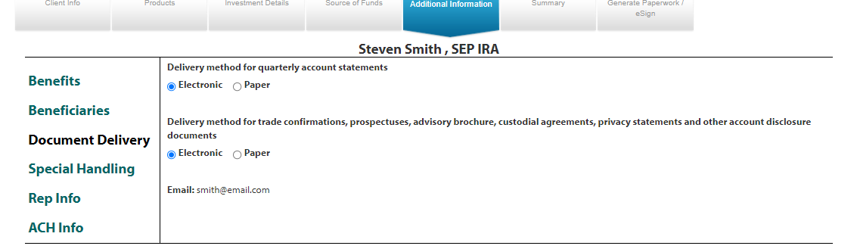

Special Handling

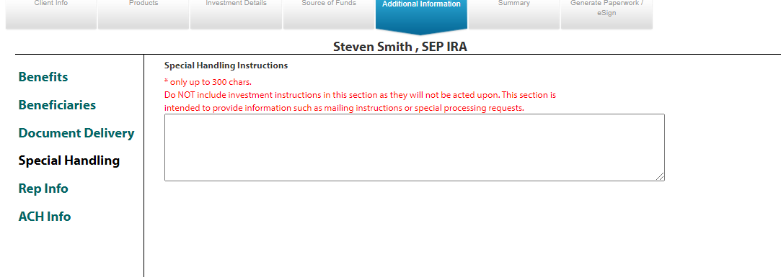

Rep Info

Rep Info to select the Rep Number of Rep. Some rep numbers are common for two reps.so program will ask for split percentage of the rep commission. Rep needs to fill the split percentage in this screen after selection of rep number.

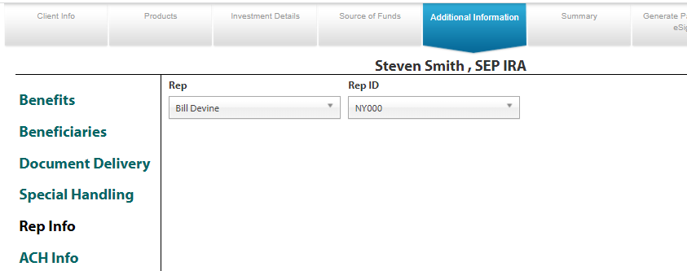

If the rep is having SDG Rep we will ask like below.

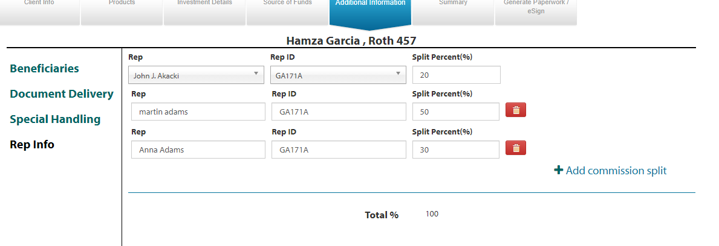

ACH Info

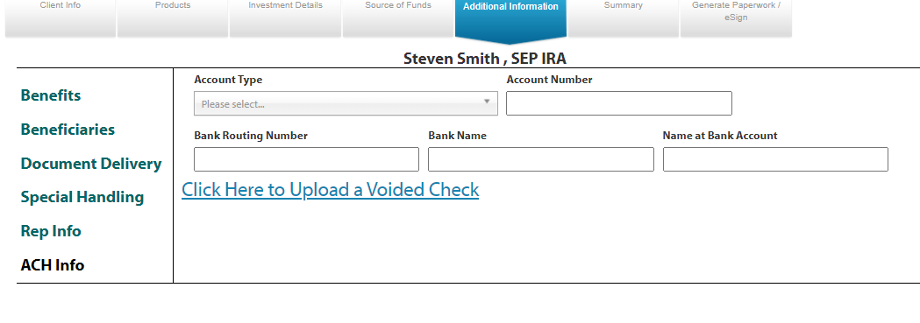

Summary:

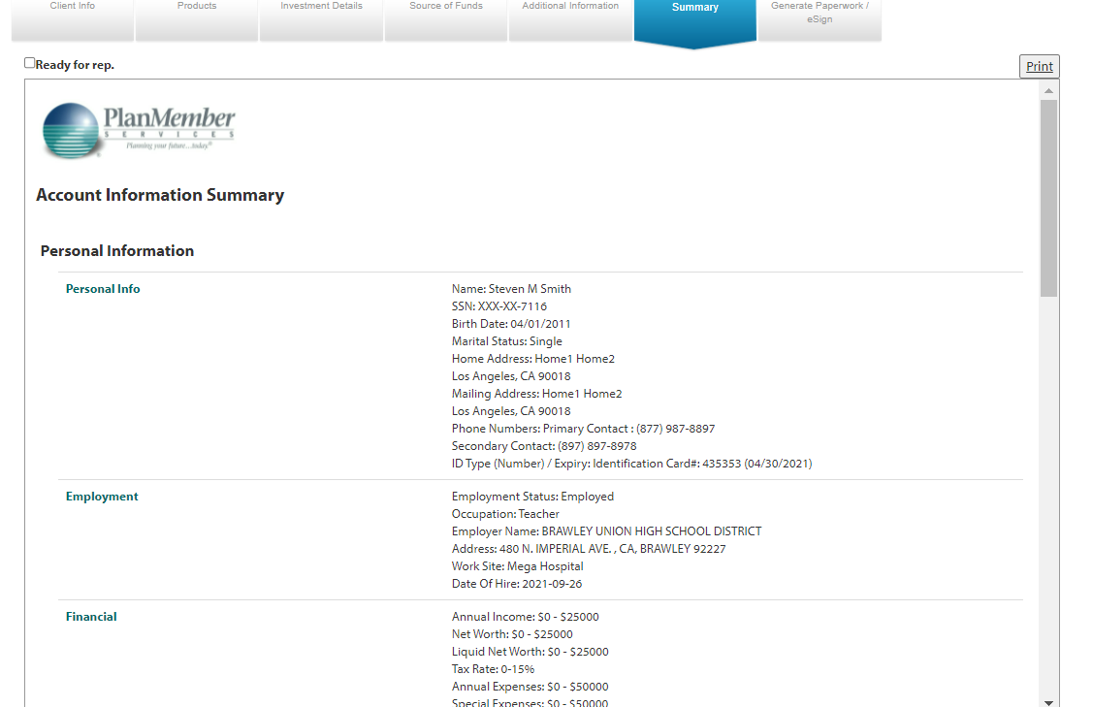

Generate paper work/ Esign:

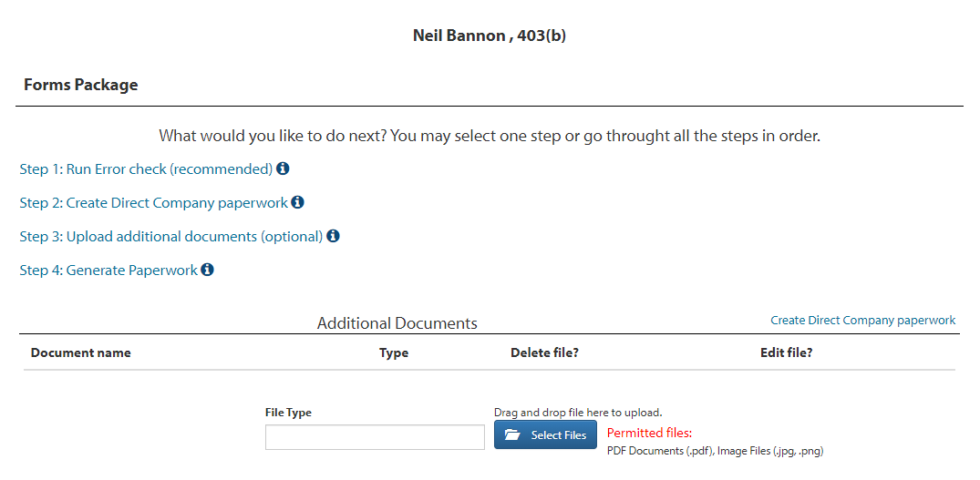

In Genenrate paperwork/esign tab we can check for errors and generate the paperwork.

If we click on Run error check/genenrate paperwork/Re-Generate paperwork/eSign, it will check the all the screens and show error message if any screen missing any data.

Run Error Check:

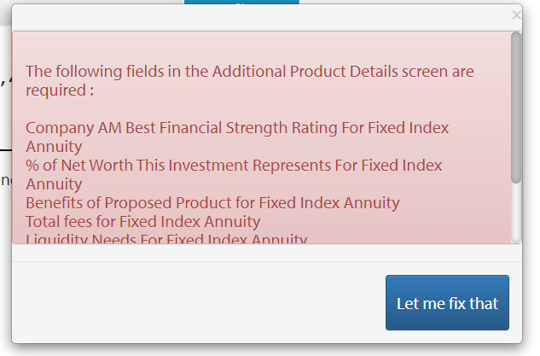

Generate paperwork/Re-Generate paper work :

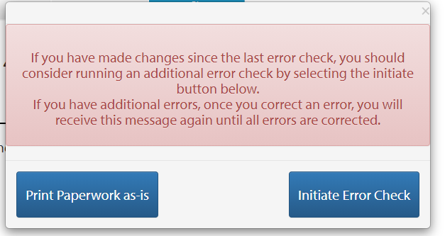

For Generate paperwork/Re-Generate paperwork, we can create paperwork & OES ID at any time (with errors also).

If we click on print paper work as-is 🡪 it will create all the pdf’s related to account type and fill will all the details what we provided in Business connect screens.

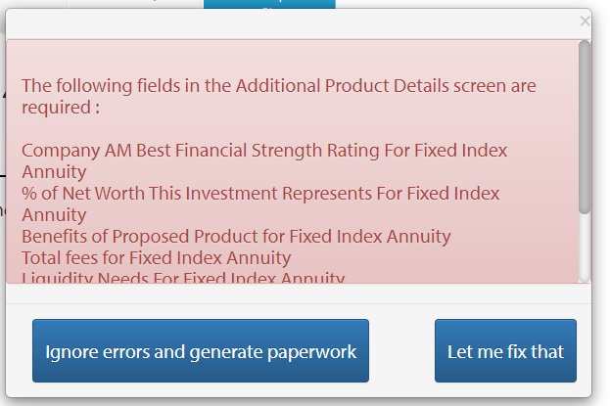

Esign :

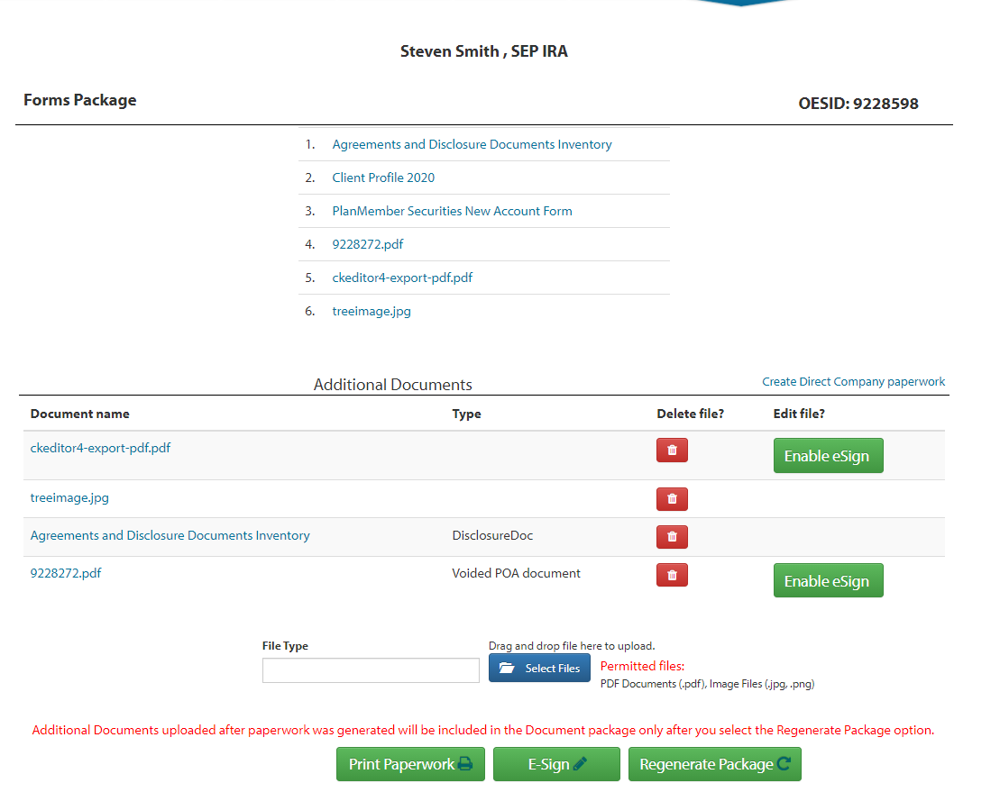

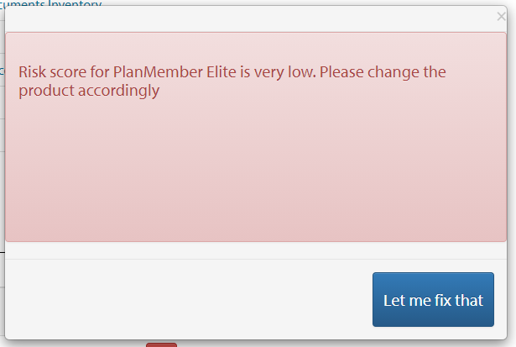

*For eSign, we need to fill all the details which is required.* Once we fill all required fields, it will open eSign screen and show us the client details and rep details.

Once we click on Send package for eSignature, In back end(OES) it will send Email to client/rep for esign.

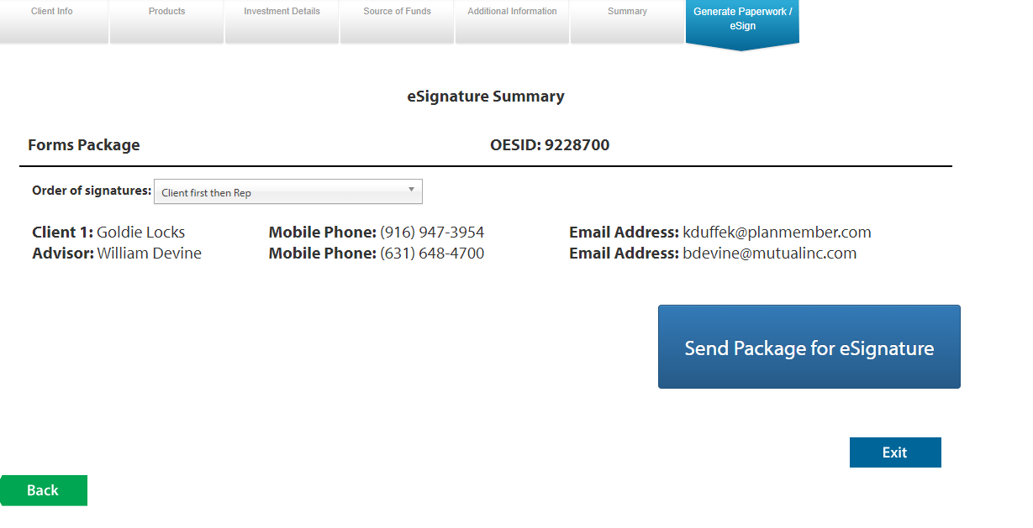

In Every screen we have 4 buttons in common



*In these buttons, if we click on cancel & Exit 🡪 it will exit the screen and redirect to dashboard without saving the data.*

*if we click on save & Exit 🡪 it will exit the screen and redirect to dashboard by saving the data.*

*NEXT & Back is for to redirect to next & back screens, before redirect to next/back screens it will save the data of current screen.*

*For Next & Back buttons, based on account types we are redirecting to different screens (you can check the code for reference of screen navigations).*

3.Business Connect Dashboard

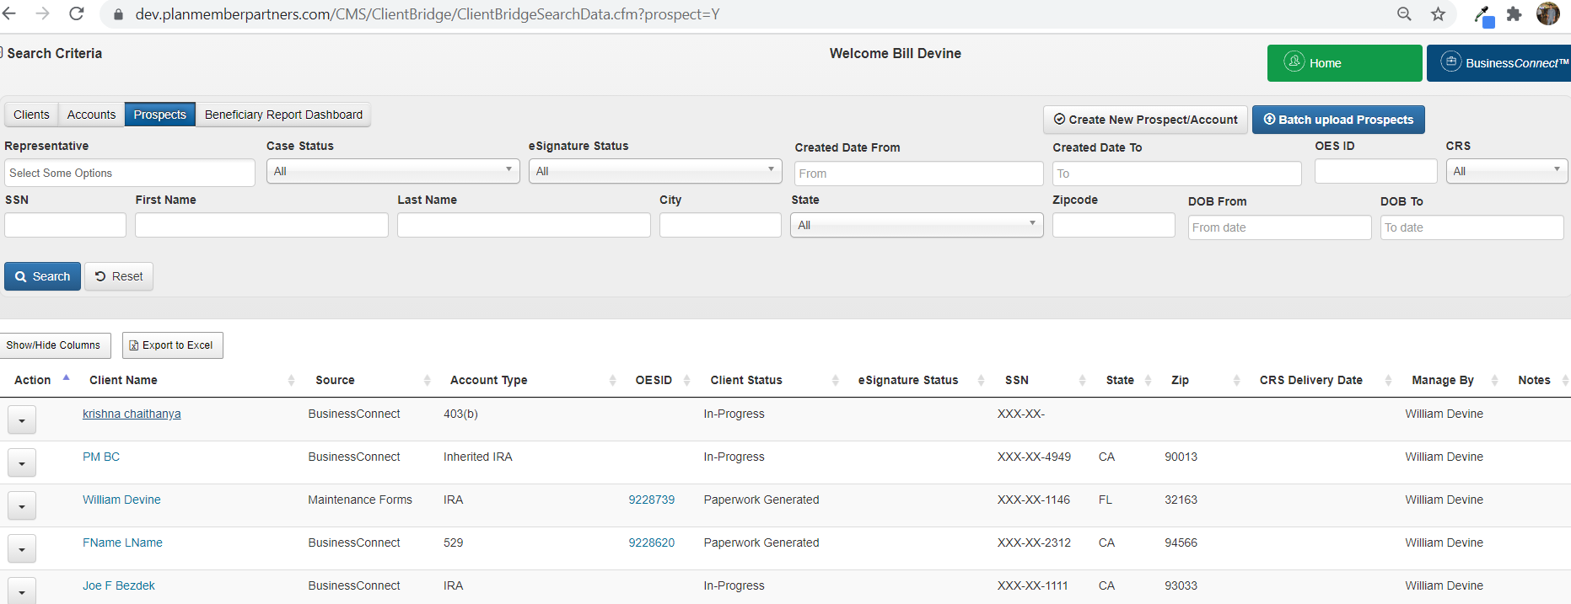

4.Deposit Checks to existing accounts

*To Add check to existing accounts, we will use this link. After clicking on this link, it will open a pop up with one text box select the client.*

*If we start entering the client name, it will auto suggest the client names which matches the text in text box.*

*When we select any client from auto suggest, it will display the existing accounts for the selected client*

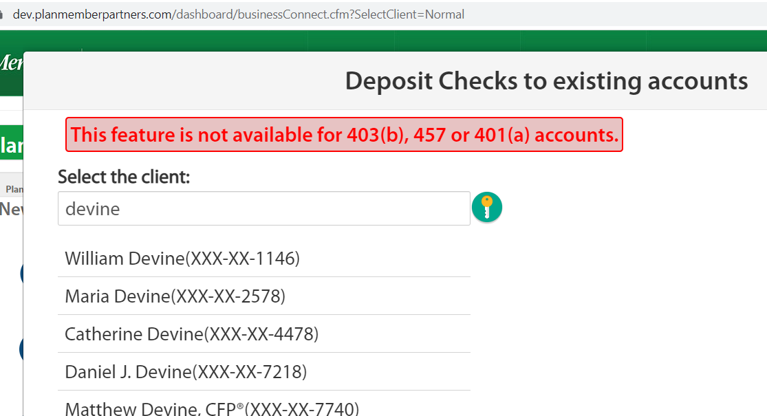

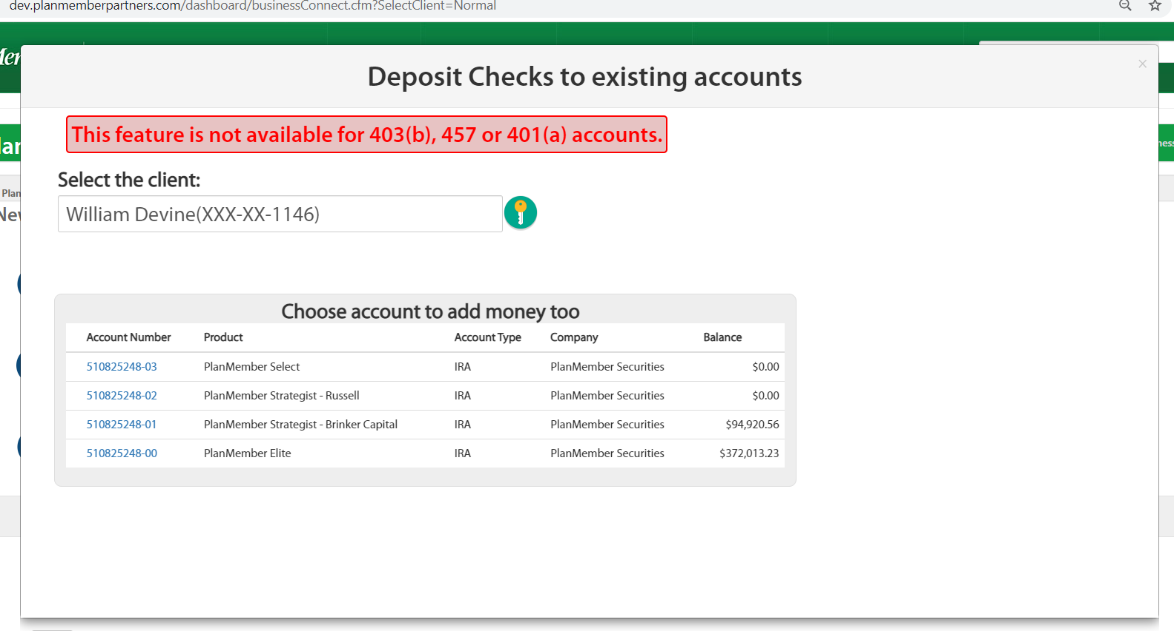

When we click on any account number, it will display the check screen. Here also we need to fill all the details of check and we need to upload the check image.

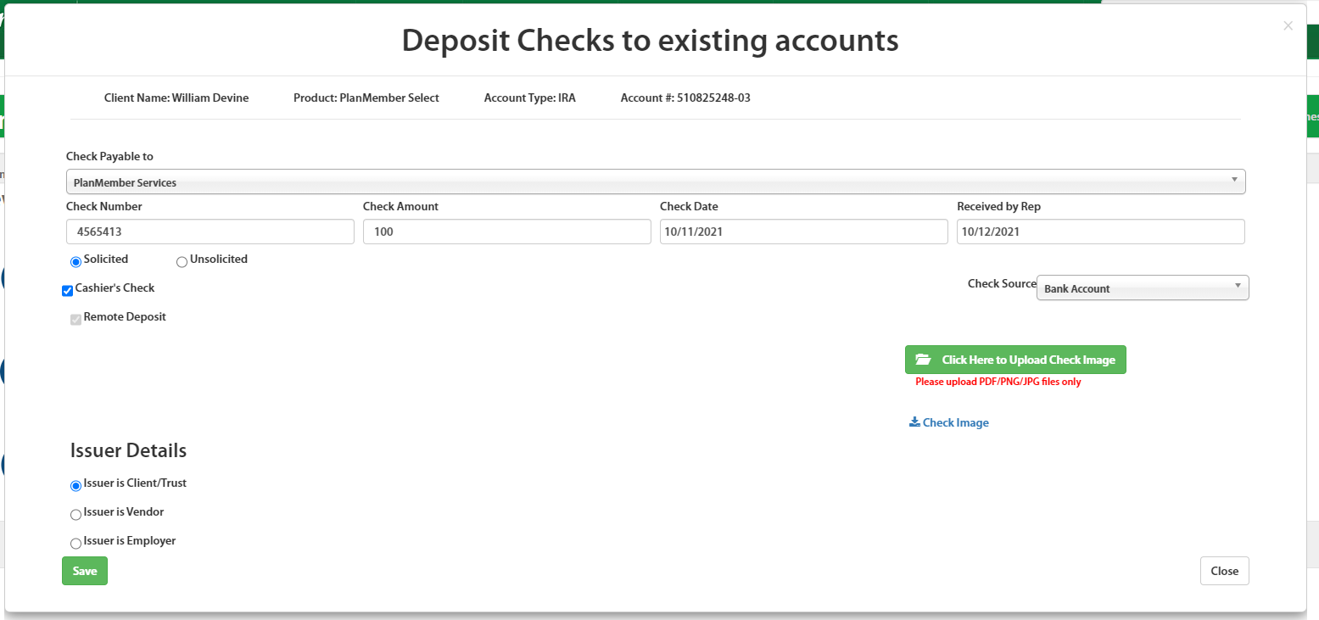

After adding check, it will show the check details like below. We can edit this check by clicking in check #

If required by clicking on Add New Check button, we can add new check also.

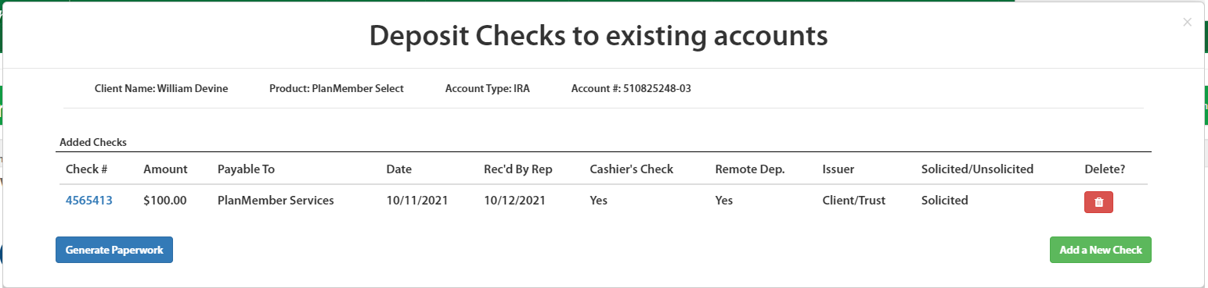

*After adding all checks*

*if we click on Generate paperwork button, it will generate the package and display the documents & OES ID.*

*It will send to eSign when we click on eSign button.*

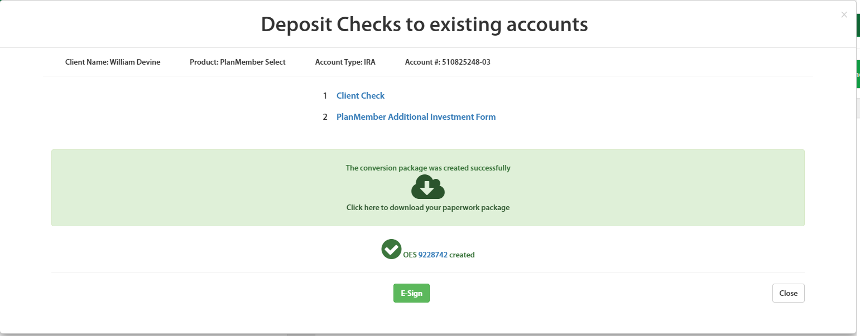

If we want to see the record in dashboard, it will display like below when we open the record

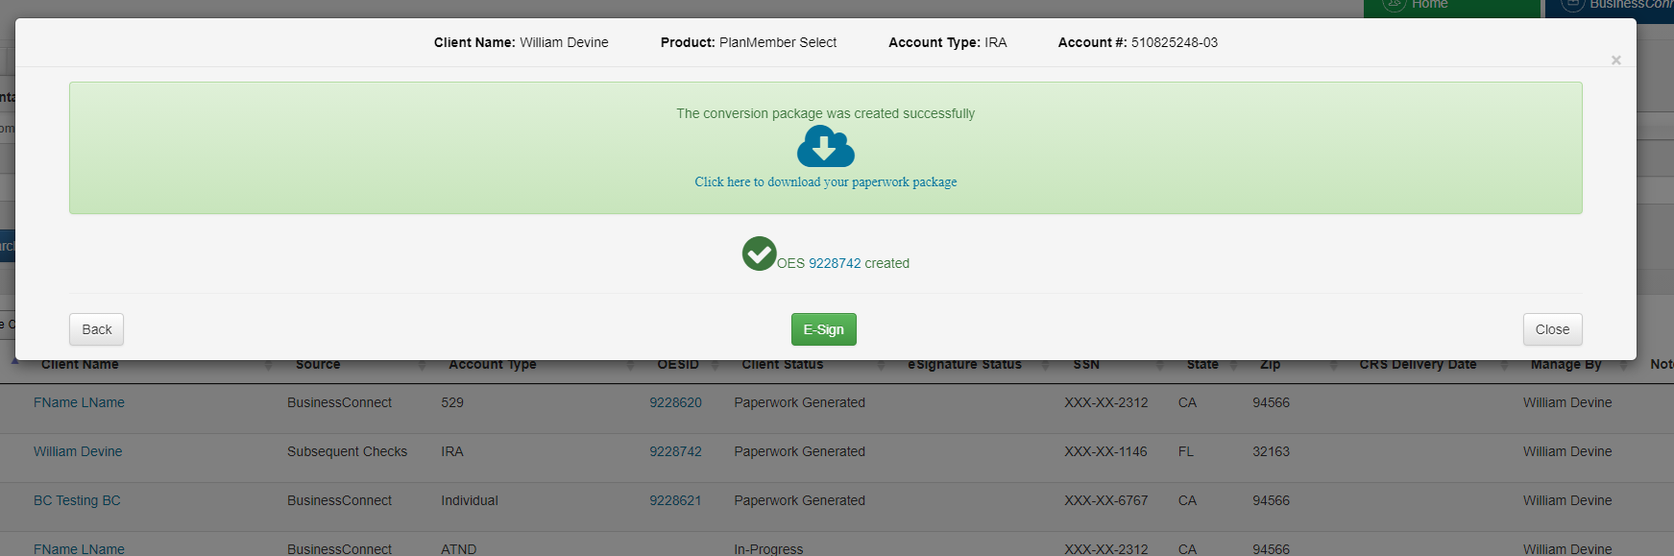

5.Transfer Direct or platform assets into a new account

*To create new account from existing account, we will use this link. After clicking on this link, it will open a pop up with one text box select the client.*

*If we start entering the client name, it will auto suggest the client names which matches the text in text box.*

*When we select any client from auto suggest, it will display the existing accounts for the selected client*

When We check the check box for existing account, it will display product, account type and Rep number to select.

Once we select everything and click on Complete paperwork online, it will create a new Business connect records by using existing account details.

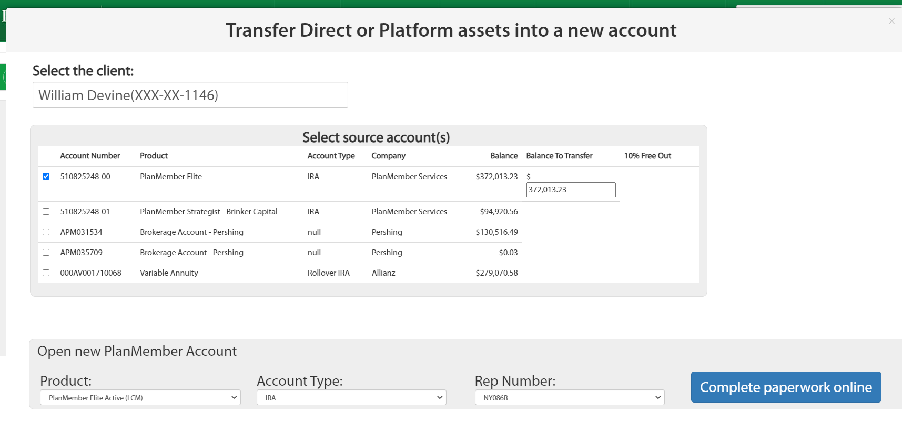

This looks normal account only.

Only difference is left side message.

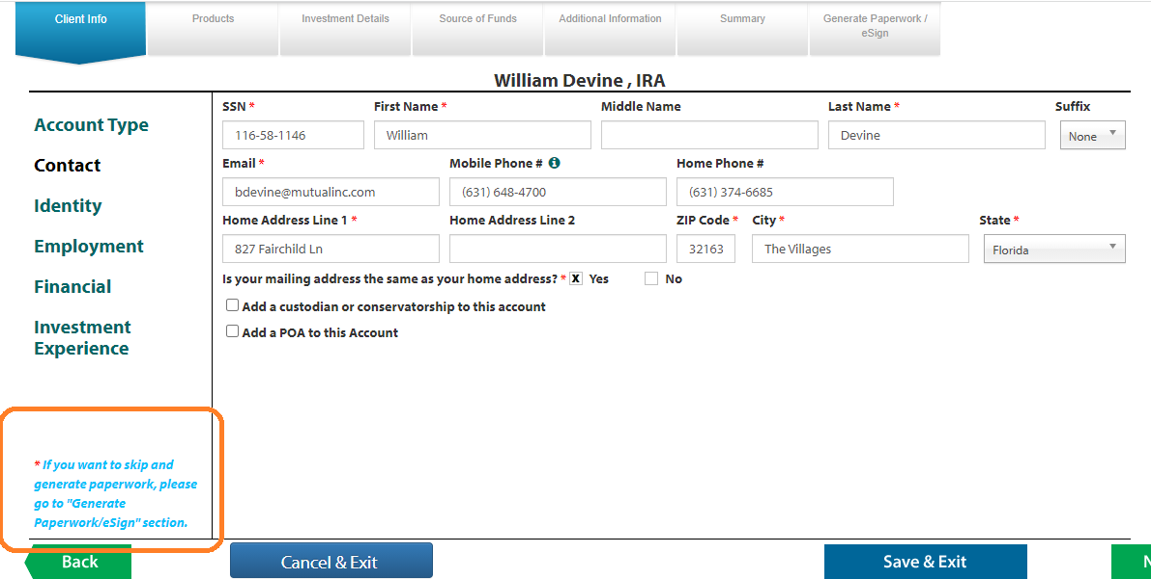

6.Subsequent or internal transfer into existing account

*To transfer money between two existing accounts, we will use this link. After clicking on this link, it will open a pop up with one text box select the client.*

*If we start entering the client name, it will auto suggest the client names which matches the text in text box.*

*When we select any client from auto suggest, it will display the existing accounts for the selected client*

When We check the check box for existing account, it will display target account to select.

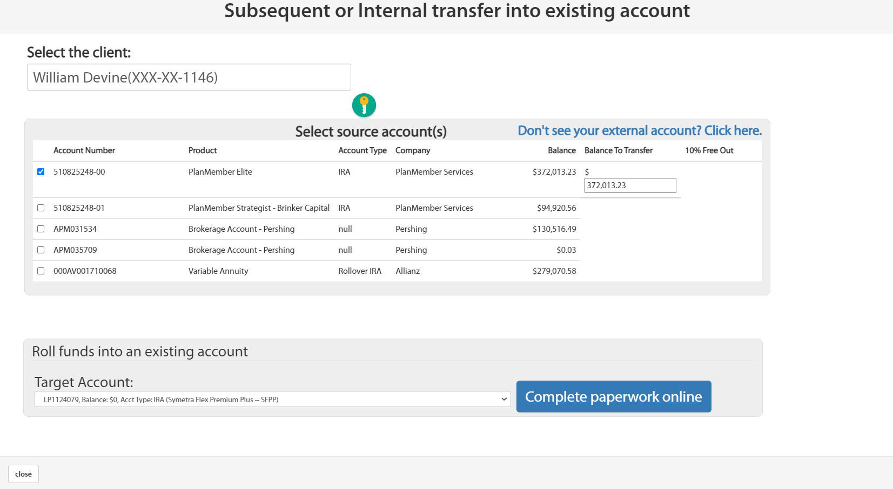

If we did not find the Source account, we can add source account by using link Don’t see your external account? Click here.

Once we click on this link, it will open Rollover page to add source account, after save it will display in source accounts.

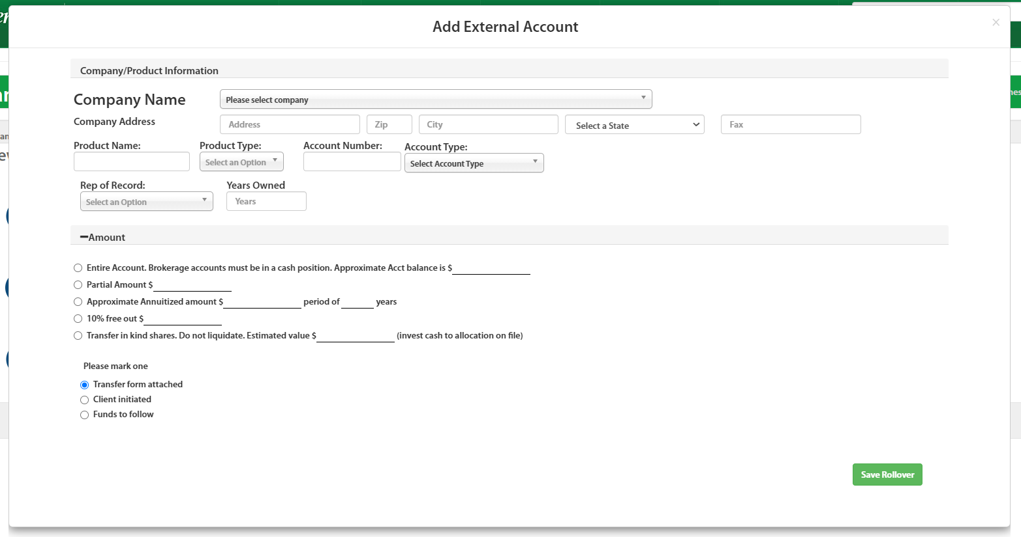

Once we select target account and click on Complete paperwork online, it will create a new Business connect record by using source & target account details.

All client info details remain same like normal account.

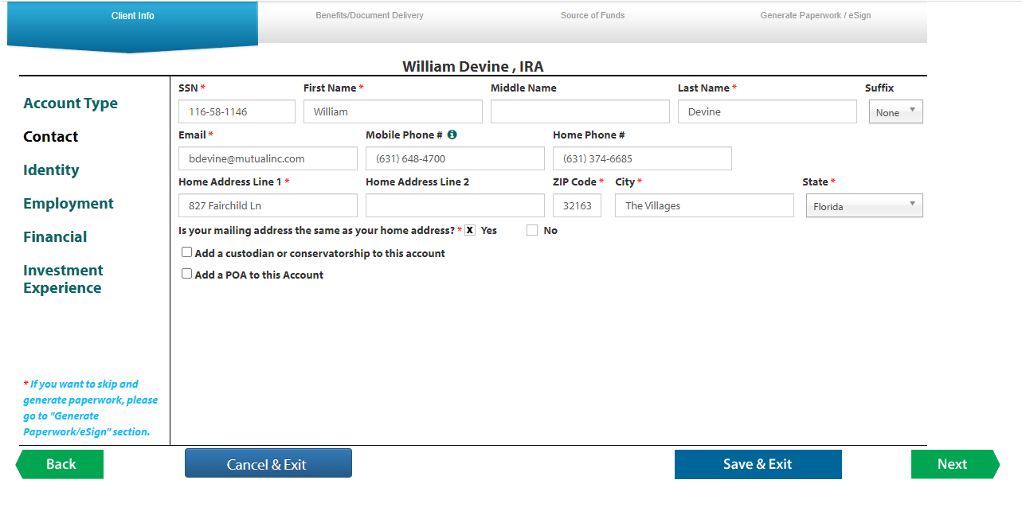

Benefits/document delivery

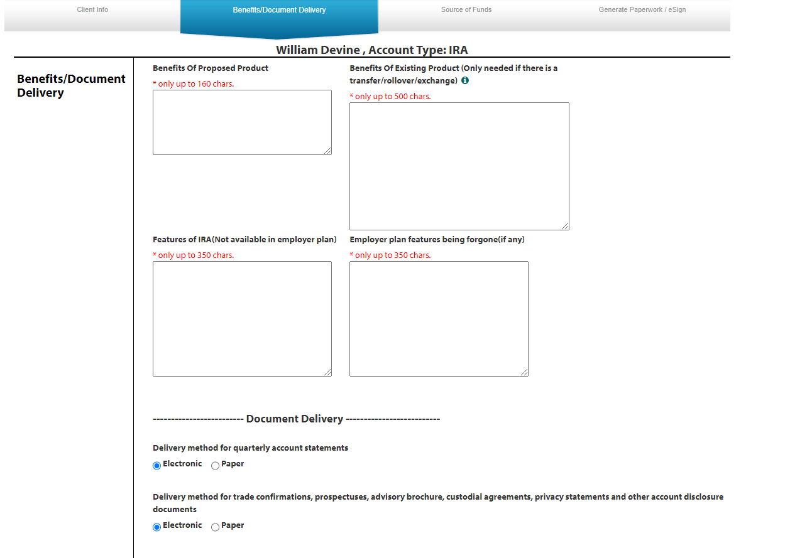

Rollovers/Transfers/Exchange

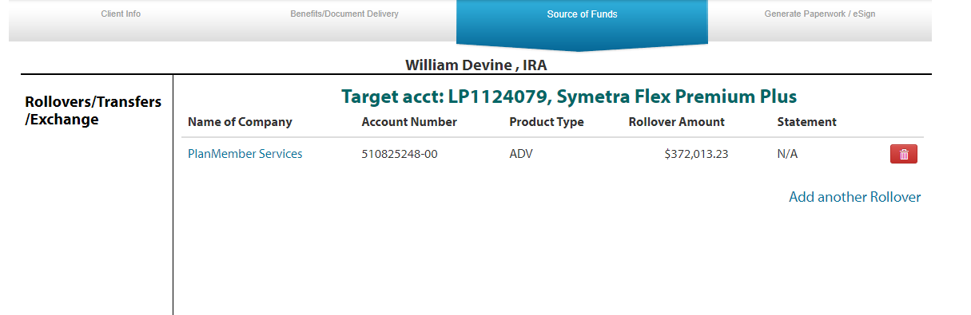

Generate paperwork/eSign

*We will show error messages for missing fields based on these screens only.*

7.Maintenance Forms

*To add documents to existing accounts, we will use this link. After clicking on this link, it will open a pop up with one text box select the client.*

*If we start entering the client name, it will auto suggest the client names which matches the text in text box.*

*When we select any client from auto suggest, it will display the existing accounts for the selected client*

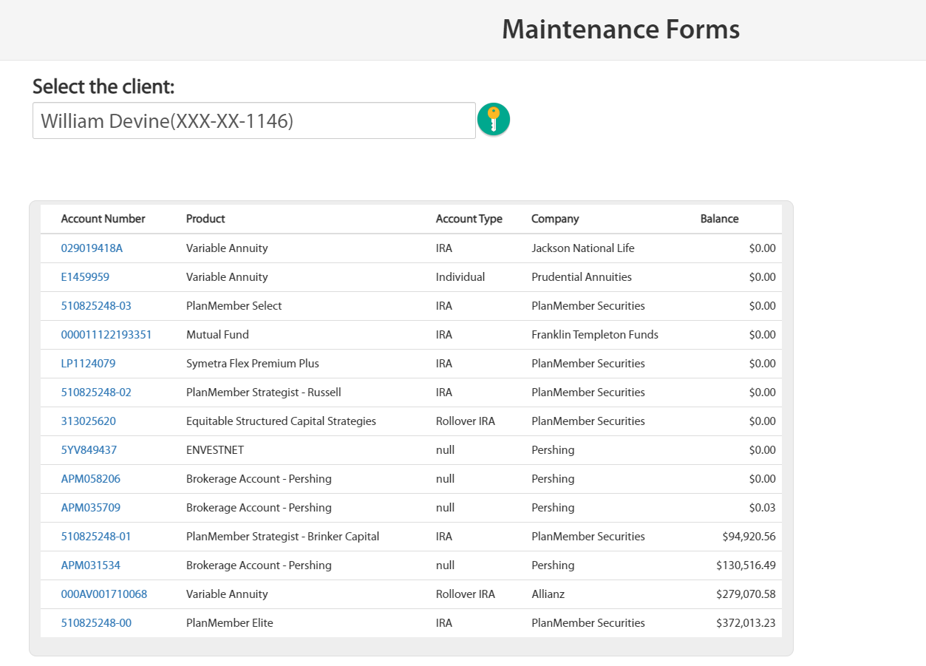

When We click on existing account, it will display Quick forms to select.

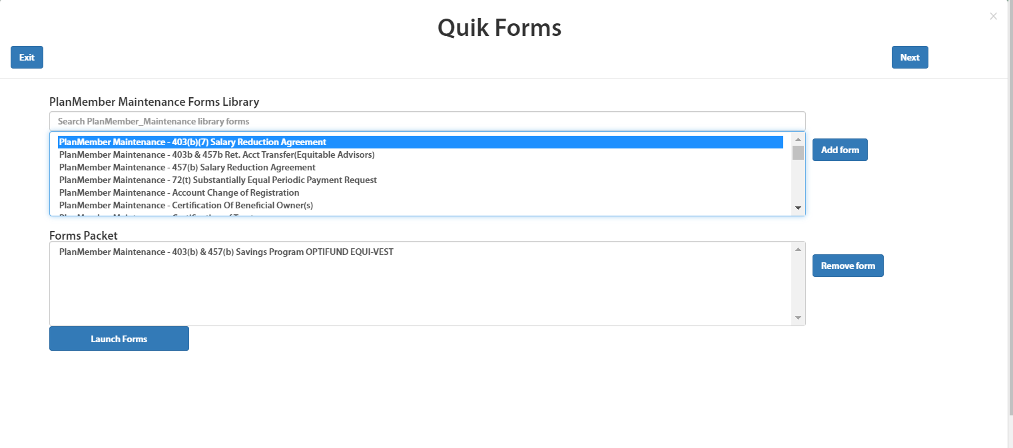

In Quick forms, we will select the document from first box and click on add item button, it will move to second box.

After that if we click on launch forms, it will open the document to edit.

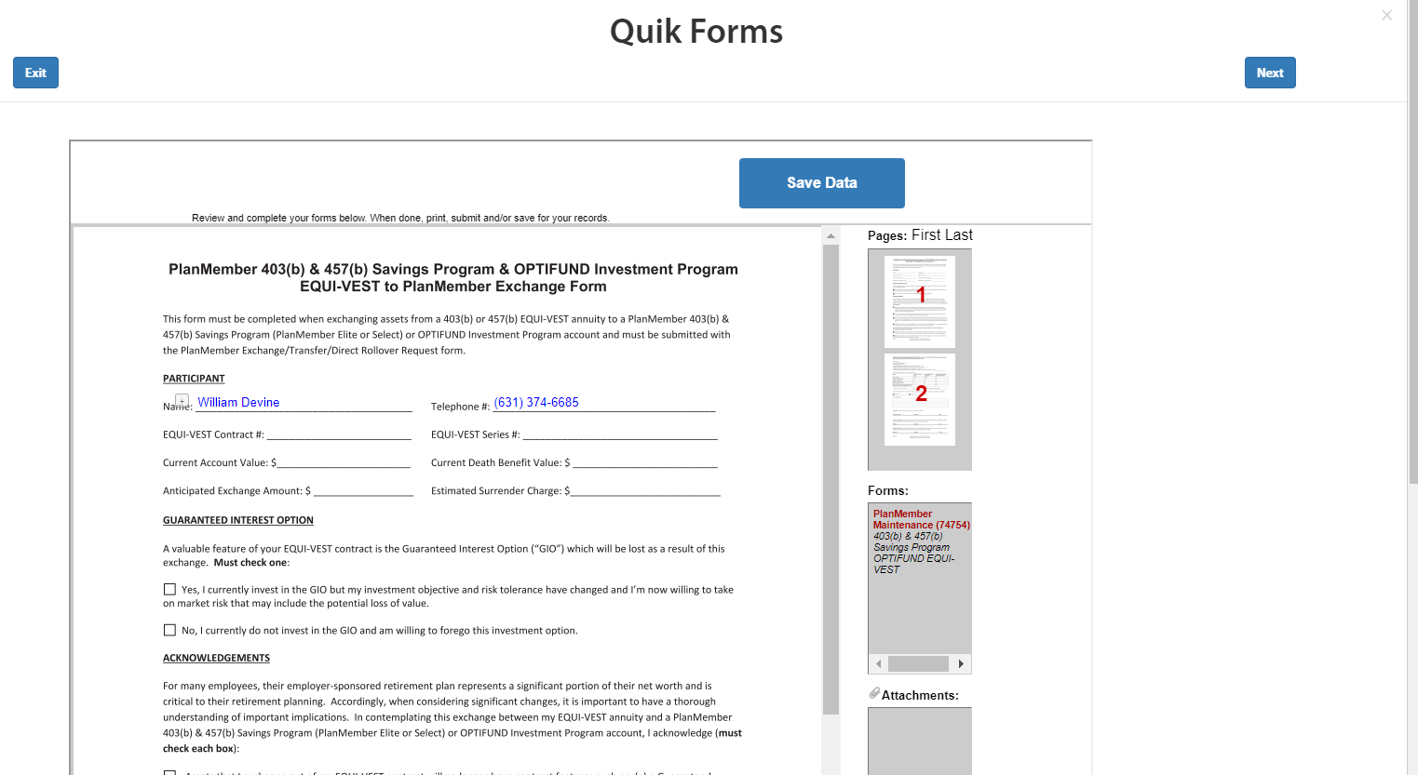

Once we click on save Data button, it will save the data.

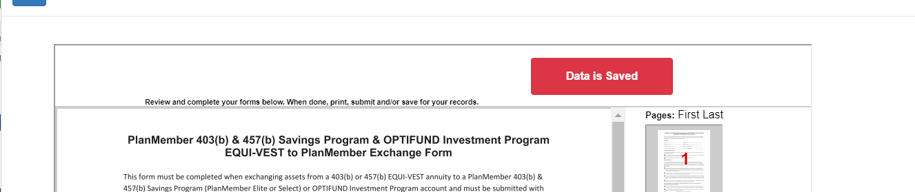

After data save, if we click on Next button it will process and shows generate paper work page directly and create OES ID.

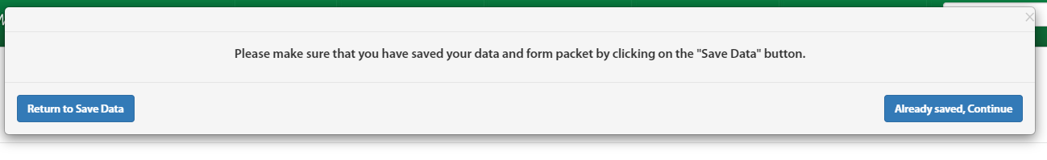

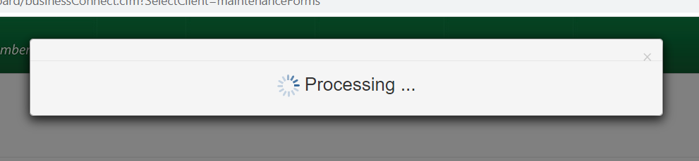

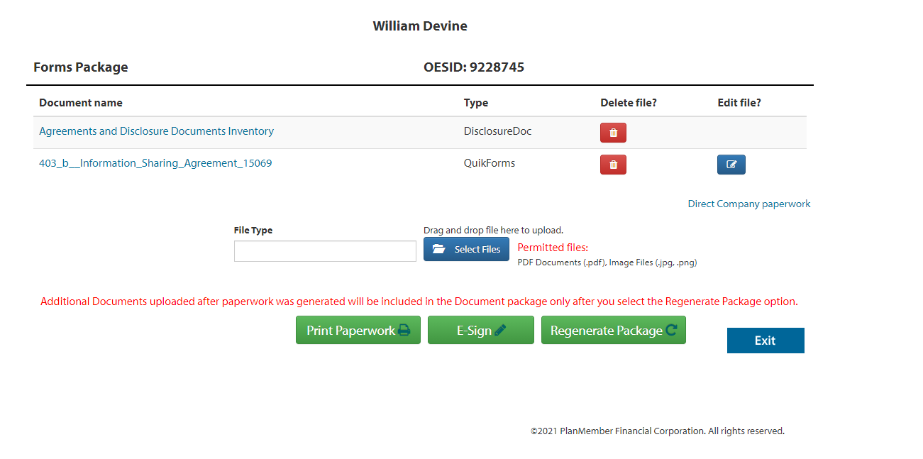

From here we can send to eSign.